САНКТ-ПЕТЕРБУРГСКИЙ ГОСУДАРСТВЕННЫЙ УНИВЕРСИТЕТ
Магистерская программа
«Исследования Балтийских и Северных стран»

АТАМАНОВ Александр Геннадьевич

«ЗЕЛЕНЫЙ» ФАКТОР В ФИНСКОЙ ПУБЛИЧНОЙ ДИПЛОМАТИИ
“GREEN” FACTOR IN FINNISH PUBLIC DIPLOMACY

Диссертация
на соискание степени магистра
по направлению 41.04.05 “Международные отношения”,

Научный руководитель –
кандидат политических наук, доцент
Д.А. Ланко

Студент:
Научный руководитель:

Санкт-Петербург
2017
Аннотация

В данном исследовании рассматривается финская публичная дипломатия. Фокус исследования направлен на роль «зеленого» брендинга в публичной дипломатии Финляндии. Исследование оперирует теорией национального брендинга для достижения целей исследования. Исследовательской базой является интервью и два официальных брендинговых сайта Финляндии – thisisFinland и toolbox.finland.fi. Для проведения исследования был применен метод контент-анализа. На основе анализа содержимого этих двух сайтов была дана характеристика финского «зеленого» бренда.
Цель работы: выявить как «зеленый» фактор проявляется в финской публичной дипломатии.
Ключевые слова: Международные отношения, национальный брендинг, «зеленый» брендинг, публичная дипломатия, Финляндия.

Abstract

This study examines Finnish public diplomacy. The focus of the research is on the role of "green" branding in Finland’s public diplomacy. The research operates with the theory of national branding to achieve the research objectives. The research base is an interview and two official country branding websites of Finland - thisisFinland and toolbox.finland.fi. To conduct the study, the content analysis method was applied. Based on the analysis of the contents of these two sites, the characteristic of the Finnish "green" brand was given
The purpose of the study is to reveal how the "green" factor manifests itself in Finnish public diplomacy.
Keywords: International relations, national branding, "green" branding, public diplomacy, Finland.
Table of Contents

1. Introduction 6
1.1 Aim and objectives of the study 7
1.2 Object and subject of the study 7
1.3 Research questions 8
1.4 Research design 8
1.5 Data collection and methods 10
1.6 Previous research and theory 10
2. Theoretical framework 13
2.1 Public diplomacy and Soft Power 13
2.2 Neoliberalism 15
2.3 Place branding 15
2.4 “Green” branding 19
2.5 Summary 20
3. Methodology 22
3.1 Data collection & the analysis 22
3.1.1 “ThisisFINLAND” website 22
3.1.2 “Toolbox.finland.fi” website 26
3.2 Quantitative content-analysis 29
3.3 Analysis of the text 30
3.4 The interview and qualitative content-analysis 31
3.5 Ethics 32
3.6 Limitations of the study 33
4. The analysis 35
4.1 The interview 35
4.2 “thisisFINLAND” 38
4.2.1 Structure of “green” tags in “green” articles 39
4.2.2 Structure of “non-green” tags in “green” articles 39
4.2.3 Degree of detachment of “green” topics 40
4.2.4 Categories 41
4.3 Toolbox and selection for analysis 41
4.3.1 Category analysis 42
4.3.2 Degree of detachment of Finnish “green” topics 42
4.3.3 Tag analysis 43
4.4 The structure of Finnish “green” branding 45
4.4.1 Degree of detachment of “green” topics in Finnish nation branding 45
4.4.2 The structure of Finnish “green” branding 46
4.4.3 Topics related to Finnish “green branding” 47
4.4.4 Categories in Finnish “green” brand 48
5. Finnish “green” branding 50
6. Discussion and conclusions 54
Bibliography 57
Secondary sources: 57
Primary sources: 61
Appendix 65
Appendix 1 65
Appendix 2 73
Appendix 3 95

Introduction

In 2010 the Finnish country brand delegation appointed by Minister for Foreign Affairs Alexander Stubb created a report called “Mission for Finland”. In this report measures reinforcing Finland’s international competitive edge were suggested. As a result, more than hundred missions were established for Finland by this delegation in different fields. According to minister for foreign affairs Alexander Stubb, this delegation could not set goals for the formation of the brand of Finland by force, but could only put forward proposals on this field (The Country Brand Delegation sets missions for Finland, 2010). However, this has already become a strong factor in the formation of such a brand. This experience was the first in Finnish history and was named by the Finnish Minister of Foreign Affairs Alexander Stubb as "unique, thorough and surprising" (The Country Brand Delegation sets missions for Finland, 2010). The commission was assembled in 2008 and worked for 2 years. During the delegation's work, the experts put forward their proposals for the creation of Finland's national brand and the process was completed on November 25, 2010 in the Torpparinmaki Comprehensive school in Helsinki by presenting a Final report of the Country Brand Delegation. Jorma Ollila said that the brand of Finland should be based on the already existing strengths of this country (The Country Brand Delegation sets missions for Finland, 2010).
Finland's branding tasks were also split between business, authorities, and ordinary Finns. Thereby, the task of producing organic food, was set to improve the image of the Finnish business, the creating of image of Finland as a mediator in international conflicts and a peacemaker country was set for improving the image of state structures and work on cleaning Finnish lakes and was made to improve the conditions for ordinary residents of the country. (The Country Brand Delegation sets missions for Finland, 2010). And this is not the only examples that could be cited.
The presentation of Country brand report on the November 25, 2010 in Helsinki was not only the completion of the Country brand delegation’s work, but - most importantly - the beginning of the implementation of tasks, developed and delivered by this delegation. As noted on the website of Ministry of Foreign Affairs, the place in which the audience gathered to present the Final country brand report was chosen very successfully - Torpparinmäki Comprehensive School specializes in education in the field of environmental protection, and this was highlighted in the report. Environmental values ​​were expressed even in the fact that the Country branding report itself was released in a very small print run on paper. Basically, people had to read the report in the Internet. As it seems to me, this action was one (perhaps the first) of the steps to implementation of the task of branding the country as an environmentally friendly state. The key elements of the Finnish brand were defined as “functionality, nature and education” (Final report of the Country Brand Delegation, 2010, 41). One of the most important ways of branding Finland was about improving the water quality and environment protection. “Let’s make lakes drinkable” – is a frequent tagline in this report. My acquaintance with this report was a starting point for this study.

1.1 Aim and objectives of the study

The aim of this research is to define how “green factor” manifests itself in Finland’s public diplomacy. In order to achieve this aim I will:
1) conduct and analyze the interview with the director of the Unit for Public Diplomacy of Finland
2) analyze tags of two official branding sites in Finland – “thisisFINLAND” and “toolbox.finland.fi”
3) analyze the texts of articles on the branding site "thisisFINLAND".

1.2 Object and subject of the study

The object of this dissertation is the public diplomacy of Finland. I see the Finnish brand as the tool for Finnish public diplomacy, part of “soft power”. I will discuss the bond between a nation brand and country’s soft power in the theoretical chapter. In the case of Finland, improving country’s public diplomacy and implementing “soft power” by using branding technologies is quite important because Finland hopes to develop its tourism, economy, and international status by developing its image (Final report of the Country Brand Delegation, 2010, 11), business, culture, foreign policy, and the effective achievement of objectives (Ibid., 255).
According to “The Soft Power 30” – the index of country’s soft power made by “Portland” communications consultancy – Finland is on 14th position (between Denmark and Norway) with 62.13 points in 2016. Among its strengths, the “impressive ability of combining practical and aesthetic” (The Soft Power 30) was mentioned, among the weaknesses there were difficulties with mass export of the Finnish brand because of small population and absence of major cultural ambassadors. Overall recommendations to Finns from compilers of “The Soft Power 30” index was about making more “digital buzz” by Finnish people and to promote such civil-governmental organizations like “SITRA” – organizations that create greener and more sustainable Finland. SITRA – is a public fund that works on developing Finland’ “well-being” (SITRA). Particularly they work at developing Finland’s society, ecology, economy (Ibid.). It is “a prime example of the kind of content Finns should be promoting to the world” (The Soft Power 30). It enforces my assumption about the importance of “green branding” in Finland’s place/nation branding and public diplomacy. Finnish “green” branding appears in this study as a subject of the research.

1.3 Research questions

The main questions of my research are:
- What place “green branding” takes in Finnish public diplomacy? What meaning it has for Finland’s public diplomacy?
- What are the weak elements of Finnish “green” branding?

Sub-questions:
1) How “place branding” is conducted in Finland?
2) What place “green branding” takes in building “place branding” in Finland?
3) From what elements does “green branding” consist in Finland?
4) How does the “green” branding relate to other place branding elements?

1.4 Research design

The dissertation consists of five chapters, introduction, conclusion, list of references and appendix. The chapter "Literature review" provides a set of already existing studies on national branding, public diplomacy, "green" branding. Also, studies on the above topics, but related to Finland are presented - studies on Finland's branding and its public diplomacy occupy a small part of all presented studies, which allows me to fill out a research gap in my dissertation in the study of Finnish public diplomacy and “green” branding.
In the first chapter an analytical, critical review of the literature on this topic was done. The chapter describes what, by whom, when, on what material had already investigated topic of “green” branding and topics close to it. I also note that I have not found any other research on the topic of "green" branding in Finland. This means that my research fills this research gap. Approaches, theories are also discussed there. The theoretical chapter contains definitions of all the key terms associated with my thesis and necessary for understanding the basics of the study. The terms "public diplomacy", "national branding", "place branding", "green branding" are defined in the second chapter. Also, a brief history and a brief outline of the theoretical school of neoliberalism is shown in this chapter, within which my research is conducted.
The “Methods” section provides a detailed description of the methods for collecting and analysis of data, justification of their selection, indication of limitations in the application of methods, limitations of the collected data set. The section also describes the interview characteristics and characteristics of informants. The characteristics of the analyzed texts, the criteria for which the sample was made are given.
The analytical chapter describes the process of the analysis, gives the results of the study (results of qualitative analysis of the interview, results of a quantitative analysis of the two branding websites). The next chapter "Finnish "green" branding" tells about the progress of the research and the results of a qualitative analysis of the websites "thisisFINLAND" and "toolbox.finland.fi".
The conclusion summarizes the study and outlines the main findings of the study. There are explanations of the results of solving the research problems, whether the main hypotheses have been confirmed. In conclusion, some theses of the main part are repeated, but in a shorter and more generalized form, summing up the thesis.

1.5 Data collection and methods

The data for analysis was collected from one interview with the Director of Unit for Public Diplomacy of Ministry for Foreign Affairs in Finland, General Secretary of the Finland Promotion Board – Petra Theman. Besides the interview, the data from two official country branding websites was collected: the texts of 62 articles from the “thisisFINLAND” website were analyzed by using a qualitative and quantitative content-analysis and 122 images from the “toolbox.finland.fi” website were analyzed by using a quantitative content-analysis. These two websites are published by Finland Promotion Board – an organization of people that create the image of Finland professionally.
In my study the qualitative and quantitative content analysis were used for analyzing the data. The qualitative content analysis was used for analyzing the interview with the Director of Unit for Public Diplomacy of Ministry for Foreign Affairs in Finland, General Secretary of the Finland Promotion Board – Petra Theman and for analyzing the texts of the articles of the website “thisisFINLAND”. Qualitative content analysis is defined as “a research method for the subjective interpretation of the content of text data through the systematic classification process of coding and identifying themes or patterns” (Hsieh & Shannon, 2005, 1278). It is “an approach of empirical, methodological controlled analysis of texts within their context of communication, following content analytic rules and step by step models, without rash quantification” (Mayring, 2000, 2).
The tags of articles and categories of articles on “thisisFINLAND” website and tags of images and folders (categories) of images on the “toolbox.finland.fi” website were analyzed by quantitative content-analysis. The quantitative content-analysis was chosen for analyzing tags, categories, and folders because of the big amount of data. “In addition to words, themes and other elements that denote the content of messages, there are other units that allows to conduct a quantitative content analysis. In this case, the researcher is not interested in what is being said, but interested in how and how many is said” (Mangeim & Rich, 1997, 283).

1.6 Previous research and theory

For discussing the “green” factor in Finnish public diplomacy this study operates in terms of “green” branding. Green branding is a part of nation branding theory. Nation branding is defined as “the application of corporate marketing concepts and techniques to countries, in the interests of enhancing their reputation in international relations” (Kerr, Wiseman, Geoffrey, 2013, 354). Nation branding in its turn appears as a part of Public Diplomacy, defined as a “government communication aimed at foreign audiences to achieve changes in the “hearts and minds” of the people” (Szondi, 2008, 6)”. There are issues about the finding the relations between Nation branding and Public diplomacy, described in the “Theoretical framework” chapter but in this study, I consider place branding as a part of public diplomacy.
A green brand, according to Insch (2011, 284), is a brand where environmental values form the brand essence. “Although the selective positioning and promotion of places based on their natural attractions and environmental credentials is nothing new, with increasing recognition and awareness of environmental issues, emphasis on aspects of environmental sustainability in both product and place branding have become more frequent”. (Ibid., 283). “Green” brand positioning was researched by Hartmann, P., Apoalaza Ibáñez, V. & Forcada Sainz, F.J. (2005). In their research two strategies of “green” brand positioning were defined: functional and emotional strategy. Brand positioning is the “act of designing the company’s offering and image to occupy a distinctive place in the target market’s mind” (Kotler, 2000: 298). “A green positioning strategy based on functional brand attributes aims to build brand associations by delivering information on environmentally sound product attributes. This positioning strategy should be based on relevant environmental advantages of the product compared to competing conventional products, and may refer to production processes, product use and/or product elimination” (Meffert and Kirchgeorg, 1993; Peattie, 1995 in Hartmann et al., 2005, 11). The emotional benefits should bring the feeling of well-being of a customer, should express the customer’s environmental consciousness and should provide a feeling of contact with nature (Hartmann et al., 2005, 11).
Finnish nation branding has been researched by Schatz, Popovic & Dervin (2015). They studied Finnish education as a source for Finland’s nation branding. Carolin Winter (2009) studied images and stereotypes of Finland’s tourism marketing. She conducted the analysis on the basis of the visitfinland.com website. In the study, Caroline Winter applied to a nation branding theory but the accent of the study was not the branding but of the perception of image of a country. Meurman studied perception of “green” branding among Finnish textile producers. This study does not relate to the nation branding theory. The data was collected by conducting interviews. I have not been able to find research on the "green" branding in Finland. None of the works found does not address this topic. Consequently, there is a research gap that I plan to fill out in this study.

Theoretical framework

Before answering the research questions, all terms must be clearly defined. For this, in this chapter the theoretical issues will be discussed. A review of the concept of neoliberalism as the main theory in my study will be given. Terms of branding, nation branding, "green" branding and their interconnection and the connection of these in terms with the concept of "soft" power within the framework of the neoliberal theory will be defined.

2.1 Public diplomacy and Soft Power

In Finland’s Ministry for Foreign Affairs website public diplomacy is defined as “cooperation to increase Finland’s influence, appeal and visibility worldwide” (Ministry for Foreign Affairs s.a.). This definition follows a traditional public diplomacy definition such as “government communication aimed at foreign audiences to achieve changes in the “hearts and minds” of the people” (Szondi, 2008, 6). The term “Public diplomacy” appeared in 1965 in the Murrow Center brochure and it was defined as a type of diplomacy which “deals with the influence of public attitudes on the formation and execution of foreign policies. It encompasses dimensions of international relations beyond traditional diplomacy; the cultivation by governments of public opinion in other countries; the interaction of private groups and interests in one country with another; the reporting of foreign affairs and its impact on policy; communication between those whose job is communication, as diplomats and foreign correspondents; and the process of intercultural communications" (Cull, 2006).
Public diplomacy’s practice is divided into elements: “listening, advocacy, cultural diplomacy, exchange diplomacy and international broadcasting (IB)” (Cull, 2008, 32). "Listening" allows to respond to external impulses – to hold a series of information campaigns (advocacy), correcting country’s behavior and correcting the image of the subject of public diplomacy. This, in turn, contributes to the achievement of the main goal - establishing a dialogue even with those who are negative about the activities of the country. Cultural diplomacy means a series of the country’s activities to improve the image of the state by promoting its language and other cultural characteristics in the international arena. There are disputes regarding cultural diplomacy. Some scholars believe that cultural diplomacy does not belong to public diplomacy, but is an independent type of diplomacy. But Cull bonds it with public diplomacy in his study. Exchange diplomacy involves the exchange of students between countries or the invitation of students to demonstrate the positive aspects of the country. Exchange diplomacy can also operate not by students, but most often it is student exchanges. During the exchanges, students share the experience of living in their countries and experience life in the inviting country. And the last element of public diplomacy – international news broadcasting - literally means spreading of news. This helps in reporting the official position of the authorities. (Cull, 2008, 21-26)
In Joseph Nye’s study “Public Diplomacy and Soft Power” he discusses the relationships between public diplomacy and soft power and argues the role of public diplomacy as the instrument of “smart power” that in its turn means the ability to combine “soft power” and “hard power” (Nye, 2008, 107-108). Nye claims that “hard power” is “the ability to use the carrots and sticks of economic and military might to make others follow your will” (Nye, 2003), ‘the ability to get others to act in ways that are contrary to their initial preferences and strategies’ (Nye, 2011, 11). But according to Nye’s soft power theory, the main source of power of the state is not the “hard power” (security, force) but “soft power”, which is “the ability to shape the preferences of others” (Nye, 2004, 5).”, “the ability to attract, and attraction often leads to acquiescence” (Ibid.,6), “the ability to get others to want the outcome you want because of your cultural or ideological appeal” (Ibid., 11).
Soft power theory can be understood within the IR school of neoliberalism. When developing one of the bases of neoliberalism - theory of “complex interdependence”, R. Keohane and J. Nye introduced the notion of “complex interdependence”: “a world in which security and force matter less and countries are connected by multiple social and political relationships” (Keohane & Nye, 1998, 83). This highlights the role of public diplomacy and soft power as a good tool for promoting the state in conditions of interdependent world. The theory of the complex of interdependence was developed by Robert O Keohan and Joseph Nye in 1970 and immediately became a strong opponent for neorealism. The early definition of interdependence was introduced in 1977: “Dependence means a state of being determined or significantly affected by external forces. Interdependence, most simply defined, means mutual dependence. Interdependence in world politics refers to situations characterized by reciprocal effects among countries or among actors in different countries” (Keohane& Nye, 1977, 8).

2.2 Neoliberalism

It is believed that the neoliberal theory of international relations appeared in the International Relations theory thanks to Robert Keohane and Joseph Nye. The “After hegemony” book by Robert Keohane, published in 1984, is considered a classic of this trend in International Relations. Neoliberalism originally appeared as a response to neorealism. Robert Keohane and Joseph Nye began to criticize neorealism on the following points:
First, the neorealists expressed their doubts that the states are the main actors on the international arena. Secondly, authors criticized the belief of the neorealists that power is a profitable way of conducting the foreign policy of the state. Third, the existence of a hierarchy in international relations was discussed (Keohane, Nye, 1977, 23-24).
As for the actors in international relations, like the classical liberals, neoliberals believe that the state is not the main and not the only actor on the international arena. The influence of international organizations, transnational corporations, individuals and others is recognized (Keohane, Nye, 1977, 3). The theory of complex interdependence has emerged as a result of the increasing number of actors on the international arena. Neoliberals recognize that a growing number of international actors have negative consequences - a diversity of threats is growing together with the number of actors. The theory of complex interdependence offers a solution to this problem. As an alternative to "hard power", neoliberals introduced the notion of "soft power", which has already been discussed above.

2.3 Place branding

What is a “brand”? The concepts of "brand" and "branding" do not have one clear definition. The concept of "brand" over the past few decades past through a lot of changes. In the Pocket Oxford Dictionary of Current English (1934) it is said that the “brand” is a: “1. n. Piece of burning or smouldering wood, torch, (literary); sword (poet.); iron stamp used red-hot to leave an indelible mark, mark left by it, stigma, trade-mark, particular kind of goods (all of the best bb.). 2. v.t. Stamp (mark, object, skin), with b., impress indelibly (is branded on my memory)” (The Pocket Oxford Dictionary of Current English, 1934 in Clifton et al., 2004, 13). The Oxford American Dictionary (1980) in its turn says that the brand is “a trade mark, goods of a particular make: a mark of identiﬁcation made with a hot iron, the iron used for this: a piece of burning or charred wood, (verb): to mark with a hot iron, or to label with a trade mark.” (The Oxford American Dictionary, 1980 in Clifton et al., 2004, 13) It shows the difference in the meaning of the term “branding” in almost 50 years. The commercial sense of the “brand” had become on the first place.
In modern days, the branding is defined as a "name, term, design, symbol, or any other feature that identifies one seller's good or service as distinct from those of other sellers" (American Marketing Association. Dictionary, 1995). "A brand is a customer experience represented by a collection of images and ideas; often, it refers to a symbol such as a name, logo, slogan, and design scheme. Brand recognition and other reactions are created by the accumulation of experiences with the specific product or service, both directly relating to its use, and through the influence of advertising, design, and media commentary." (American Marketing Association. Dictionary, 1995)
What does the “branding” mean? Branding is “a disciplined process used to build awareness and extend customer loyalty. It requires a mandate from the top and a readiness to invest in the future. Branding is about seizing every opportunity to express why people should choose one brand over another. Desires to lead, to outpace the competition, and to give employees the best tools to reach customers are the reasons why companies leverage branding” (Wheeler, 2009, 6). Applying the branding on the places, the more complex terms begin to emerge: “Branding […] is not only about “selling” products, services and ideas, it is not only about gaining market share and attention, it is also about managing identity, loyalty and image” (van Ham, 2002, 267).
The Ministry for Foreign Affairs of Finland claims that Finnish “public diplomacy is based on Finland’s real strengths, which serve as the base for building a strong country brand, i.e. Finland’s international distinctive features” (Ministry for Foreign Affairs). According to Ying Fan (2008, 164), the state through place branding can achieve goals in promoting its values and its products in the international area and hence it can be an instrument of public diplomacy and soft power. Accordingly, there is a connection between place branding, public diplomacy and soft power.
The meaning of place branding cannot be clearly defined. It is an interdisciplinary field and its definition defends on the point of view of the researcher. The definition from the marketing perspective claims that “place branding is defined as the practice of applying brand strategy and other marketing techniques and disciplines to the economic, political and cultural development of cities, regions and countries” (Ashworth and Kavaratzis, 2007,521). Van Ham defined it “can be considered an effort to manage, if not necessarily wield, the social power of a geographical location by using strategies developed in the commercial sector” (2010, 136).
“If a place, product or service acquires a positive, powerful and solid reputation, this becomes an asset of enormous value – probably more valuable, in fact, than all its tangible assets, because it represents the ability of the place or organization to continue to trade at a healthy margin for as long as its brand image stays intact” (Anholt, 2010, 92). Various scientists have confirmed that progress of a place can be achieved only by creating and maintaining a positive brand (Pride, 2011, 140; van Ham 2008, 128 & Widler 2007, 146). For places that do not or cannot create a competitive brand it will be difficult to win their part in world consumers, capital, investments, talents, cultural exchange, respect and attention (Anholt, 2007, 11). A strong, positive brand image helps places to differentiate themselves from others (Kotler & Gertner, 2002, 249-250). Brands’ differentiating and identifying functions (Aitken & Campelo, 2011, 915) make them a powerful inﬂuence on consumer thinking, attitudes, and behavior (Heilbrunn, 2006, 106). A strong brand can “enable premium pricing, as well as the market segmentation that makes it possible to communicate a coherent message to a target customer group” (Berthon, Holbrook, Hulbert & Pitt, 2011, 41). Brands are a powerful device to communicate a preferred image of products, services, or indeed places (Campelo, Aitken & Gnoth, 2011, 3-4).
What is then the difference between the notions of “place branding” and “nation branding”? According to Olins and Hildreth (2011, 55-56), unlike place branding’s outward focus, nation branding, at least from a political or cultural-critical perspective, is associated with nation-building and characterized by an inward focus. There it is mostly perceived as a way to reconstitute nations both by means of ideology and praxis (Kaneva, 2011, 118).
But literature on nation branding does not always differ between the inward vs. outward focuses of the two concepts. In fact, the two concepts merge in their almost identical purpose to promote a certain geographical location to a target audience, to make a place’s tourism and export industries appear attractive, and to support public diplomacy efforts (Moilanen & Rainisto, 2009, 8-10). According to Anholt (2007, 11), nation branding is really just a metaphor for how effectively countries compete with each other for favorable perception, be it with regard to exports, governance, tourism, investment and immigration, culture and heritage, or people. In this sense, nation brands are not much different from the conceptualization of place brands. What is more, when perceived as ideas, emotions, or collections of perceptions both nation and place brands are largely intangible and socially constructed (Berthon, Holbrook, Hulbert & Pitt, 2011, 41). Because of that in this research terms “nation branding” and “place branding” will be considered as identical.
There are also difficulties with defining relations between “nation (place) branding” and “public diplomacy”. According to Szondi there are five possible ways to connect “public diplomacy” to “nation branding” in academic literature (Szondi, 2008, 13-18):
- Nation branding and public diplomacy are two unrelated concepts. “Nation branding has more visibility as it relies heavily on visuals and symbols and therefore target audiences are able to detect that they are exposed to another country’s branding campaigns, unlike public diplomacy, which is a more suitable operation, which relies more on behavior that symbolism” (Szondi, 2008, 16)
- Nation branding is the part of public diplomacy. According to this view on relations between these terms, nation branding appears as a tool for public diplomacy. This concept was strongly promoted by Peter van Ham (2008), Leonard et al (2002). (Szondi, 2008, 22-23)
- Public diplomacy is the part of Nation branding. Nation branding in this case is seen as a broader concept. Public diplomacy is seen as a “branding techniques of politicians” (Lewis, 2003, 27).
- Nation branding and public diplomacy are distinct but overlapped concepts. According to this approach, the formation of identity, image, culture and values is put in a zone of both spheres - national branding and public diplomacy, but recognizes these two spheres as separate (Melissen, 2005 in Szondi, 2008, 26), (Dinnie, 2008 in Szondi, 2008, 27).
- Nation branding and public diplomacy are the same concepts. As Dinnie claims that in the future these two concepts may become identical (Dinnie, 2008 in Szondi, 2008, 29)
In my research, I follow the point of view that presented in academic literature mainly by Peter van Ham (2008) and define nation branding as the part of public diplomacy (Ibid., 128). In the framework of my research I am interested in one of the fields in place branding - “green branding”.

2.4 “Green” branding

A green brand, according to Insch (2011, 284), is a brand where environmental values form the brand essence. “Although the selective positioning and promotion of places based on their natural attractions and environmental credentials is nothing new, with increasing recognition and awareness of environmental issues, emphasis on aspects of environmental sustainability in both product and place branding have become more frequent”. (Ibid., 283).
The most effective way for conducting “green” branding is “the creation of emotional benefits sustained by information on environmentally sound functional attributes” (Hartmann et al., 2005, p. 21). In the modern world, the creation of a "green" brand is becoming more relevant. Pollution of the environment, world environmental threats increase the consciousness of people in this respect. “More and more people in more and more countries feel unable to admire or respect countries or governments that pollute the planet, practice or permit corruption, trample human rights or ﬂout the rule of law” (Anholt, 2010b, 70). The focus of branding in modern society should be on the “cultural, environmental, imaginative and human qualities rather than on raw power” (Anholt, 2010a, p. 37).
Brand positioning is the “act of designing the company’s offering and image to occupy a distinctive place in the target market’s mind” (Kotler, 2000: 298). Hartmann et al. (2005, 10) claimed that “green” brand is based on the emotional benefits and/or functional attributes. “A green positioning strategy based on functional brand attributes aims to build brand associations by delivering information on environmentally sound product attributes. This positioning strategy should be based on relevant environmental advantages of the product compared to competing conventional products, and may refer to production processes, product use and/or product elimination” (Meffert and Kirchgeorg, 1993; Peattie, 1995 in Hartmann et al., 2005, 11). The emotional benefits should bring the feeling of well-being of a customer, should express the customer’s environmental consciousness and should provide a feeling of contact with nature (Hartmann et al., 2005, 11). The Hartman’s study on green brand positioning is not about state branding but about branding at all. But Dinnie (2008, 51-53) claims that brand positioning theory can be applied to the nation branding. Hartman et al. (2005, 21) suggest to use both strategies in “green” brand positioning – emotional and functional. But the “green” brand can be implemented with using one of the strategies. Hence, during the searching for elements (articles and its tags) that construct the Finnish “green” branding I looked for tags, that:
- “build brand associations by delivering information on environmentally sound product attributes” (Meffert and Kirchgeorg, 1993; Peattie, 1995 in Hartmann et al., 2005, 11)
OR
- bring the feeling of well-being of a customer. Allows to show consumer’s altruistic behavior (Hartmann et al., 2005, 11)
OR
- express the customer’s environmental consciousness (Hartmann et al., 2005, 11)
OR
- provide a feeling of contact with nature (Hartmann et al., 2005, 11)

2.5 Summary

The illustration of relations between the terms is presented in Figure 1, in which green branding is understood as one specific dimension of place branding, place branding as part of public diplomacy, and all these above mentioned as tools to use and create soft power of a country, in my case soft power of Finland.

Figure 1. Relationship between green branding, place branding, public diplomacy, and soft power

Methodology

3.1 Data collection & the analysis

3.1.1 “ThisisFINLAND” website

On the first level of analysis, the tags of articles and categories of articles on “thisisFINLAND” website were analyzed and tags of images and folders of images on the “toolbox.finland.fi” website were analyzed by quantitative content-analysis. To find answers on the research questions I collected my main data from two sources: “thisisFINLAND” website and “toolbox.finland.fi”. These two websites are published by Finland Promotion Board – the team of professionals “responsible for coordinating country brand communications” (Finland Promotion Board). First website has the collection of articles that form the image of Finland and the second website has plenty of materials (images, articles, presentations, brochures, presentations) that might help people to present Finland and to create country’s image (Story of Finland). On the main page of the “thisisFINLAND” website there is a collection of the articles. All these articles are divided into categories. There are four main categories: “Life and Society”, “Business and Innovation”, “Arts and Culture”, “Facts, stats and info” (This is Finland). There is also category “Newsroom” with compilation of news, provided by “Yle” (Newsroom). Also, there is seasonal category “Christmas” which contains articles about this holiday (thisisFINLAND). Almost all of articles are marked with a set of tags that represent main topics of each article. The article can be tagged with only one tag or by few tags. There is one main tag that is set near the main photo of the article and near the category. The main tag shows the main topic of the article which contains smaller topics within.
I faced a difficulty with defining the correct set of articles of the whole number of articles in my sample. There were some articles that related to “green” topic on my view but they were not tagged with any “green” tag. To proof the belonging of this type of articles to “green” topic I had to make a detailed content analysis of the whole website which seemed undoable in the framework of my master’s thesis. Besides articles that were tagged by “green” tags are tagged so because creators of the website (Finland promotion board (thisisFINLAND)) and people that create the Finnish brand and do Finnish public diplomacy consider these articles as a part of “green” branding. Articles that were not tagged by “green” tag but contained a “green” topic in them are also should be considered as a part of Finnish “green” brand but it is not quite clear that creators of these articles considered them so. It the framework of my research it is more important to find articles that were clearly considered as a part of “green” branding by their creators because I mainly study the “green” factor in Finnish public diplomacy but not a “green” factor in Finnish brand. In other words, my aim is not to find the perception of Finland on the base of this website but to find methods which were used by Finnish public diplomacy practitioners for creating a “green” brand. Articles on the official country branding website (Finland Promotion Board) that were tagged by a “green” tags are definitely can be considered as these methods so I made the analysis on the basis of them.
The total number of the articles on the main page of the website “thisisFINLAND” changes every day. On the day when I sampled the articles for the analysis of tags there were 594 articles (thisisFINLAND). 62 articles, which contain “green” topic, were selected for the tag analysis. The belonging of articles to the “green” topic was identified by the tags of these articles. Tags of the articles represent main topics of the articles. Being the official county branding website in Finland, on a basis of analysis of tags of the articles on the website “thisisFINLAND”, the answers on research questions on the degree of detachment of “green” topics in Finnish nation branding, the structure of Finnish “green” branding, topics related to Finnish “green branding”, categories in Finnish “green” branding were sought. As the criteria of belonging of each tag to the “green” topic, the study of Hartman et al. (2005) on the “green” brand positioning was used. Brand positioning is the “act of designing the company’s offering and image to occupy a distinctive place in the target market’s mind” (Kotler, 2000: 298) Hence, for my study I searched for topics on the country branding website that position the Finnish brand as “green”. Hartmann et al. (2005, 10) claimed that “green” brand is based on the emotional benefits and/or functional attributes. “A green positioning strategy based on functional brand attributes aims to build brand associations by delivering information on environmentally sound product attributes. This positioning strategy should be based on relevant environmental advantages of the product compared to competing conventional products, and may refer to production processes, product use and/or product elimination” (Meffert and Kirchgeorg, 1993; Peattie, 1995 in Hartmann et al., 2005, 11). The emotional benefits should bring the feeling of well-being of a customer, should express the customer’s environmental consciousness and should provide a feeling of contact with nature (Hartmann et al., 2005, 11). The Hartman’s study on “green” brand positioning is not about state branding but about branding at all. But Dinnie (2008, 51-53) claims that brand positioning theory can be applied to the nation branding. Instead of a “customer” in terms of nation branding there should be a “tourist” (for example). Hartman et al. (2005, 21) suggest to use both strategies in “green” brand positioning – emotional and functional. But the “green” brand also can be implemented using only one of the strategies. Hence, during the searching for elements (articles and its tags) that construct the Finnish “green” branding I looked for tags, that:
Express the functional strategy of brand positioning:
- “build brand associations by delivering information on environmentally sound product attributes” (Meffert and Kirchgeorg, 1993; Peattie, 1995 in Hartmann et al., 2005, 11)
OR
Express the emotional strategy of brand positioning:
- “bring the feeling of well-being of a customer. Allows to show consumer’s altruistic behavior” (Hartmann et al., 2005, 11)
OR
- “express the customer’s environmental consciousness” (Hartmann et al., 2005, 11)
OR
- “provide a feeling of contact with nature” (Hartmann et al., 2005, 11)
The list of all of the tags with names of 62 articles can be found in Appendix 1. Among all of the tags on the country branding website “thisisFINLAND” the tags “Environment”, “Nature”, “Arctic”, “Forestry”, “Baltic Sea”, “Sustainability”, “Winter”, “Cleantech”, “Recycling”, “National park”, “Organic food”, “Slush” were identified as tags that position the Finnish brand as “green”. This sample was made by myself, it is not based on a survey which can be considered as a limiting factor of my study. Each component of the sample is justified in the table below. In the first column, there are names of the tags, in the second column there are numbers that bond each tag with one of the “green” brand positioning strategy. Of course, each tag can be bond with strategies in a different way but the table below explains the most appropriate way of doing it from my point of view. The numbers repeat the enumeration of the strategies above. And the third column contains short explanations why I bonded each tag with one of the “green” positioning strategy. In references the articles will be given that represent the explanation.

Table 1. The “green” tags on the “thisisFINLAND” website
Tags | “Green” branding strategy | Notes
Environment | 1 | Articles, tagged by this tag often cause an association with the environment in its various manifestations. The example of the article: (Niemelä, 2016)
Nature | 1, 4 | Articles, tagged by this tag also cause associations with the environment and create the feeling of contact with nature (Weaver, 2011)
Winter | 1, 4 | Articles, tagged by this tag use the images of winter; snowy, cold weather to create feeling of contact with nature and to create associations with environment (Suomalainen, 2017)
Arctic | 1, 3, 4 | Articles on the topic of Arctic on the ”thisisFINLAND” website express the feeling of contact with nature, create associations with environment and call for people's consciousness in the preservation of fragile Arctic nature. (Bird, 2017)
Forestry | 1, 3, 4 | Articles depict the life of animals living in the forest, call for people’s consciousness in preserving of these animals and also create a feeling of nature and create environmental associations (Kytöoja, 2013)
Baltic Sea | 1, 3, 4 | Articles on the Baltic sea topic usually devoted to the problem of the pollution of the Baltic sea. Hence it forms the reader’s consciousness in saving the habitants of the Baltic. (Weaver, 2013a)
Sustainability | 2 | Articles, tagged by this tag and usually devoted to the sustainable development and form the feeling of well-being. (Weaver, 2013b)
Cleantech | 2, 3 | Cleantech articles create the feeling of well-being, appeal to people’s altruistic aspiration and appeal to people’s environmental consciousness. (Lyytimäki, 2014)
Recycling | 2, 3 | Articles devoted to the topic of recycling also create the feeling of well-being, appeal to people’s altruistic aspiration and appeal to people’s environmental consciousness. (Weaver, 2013c)
National park | 1, 4 | Articles on the topic of Finnish national park can be bond with all of the “green” branding strategies. They tell about places that help to preserve the nature and appeal to altruistic behavior and environmental consciousness and form associations with environment an nature. (Endangered Finnish seals get winter help from locals)
Organic food | 2, 4 | There is only one article on the website “thisisFINLAND” tagged by the tag “organic food” – the article with a list of events in different countries where the Finnish organizations are presented. The Finnish organic food were presented on a festival in Nurnberg. The organic food appeal to the feeling of well-being (Niemelä, 2016b)
Slush | 1, 3 | The article, tagged by the tag “Slush” is the same as the article, tagged by the tag “organic food” (Niemelä, 2016b). “Slush” is the name of the conference in Helsinki that will take place in November 2017 and its name appeal to the association with the Finnish weather in November (Slush)
Innovation | 2 | Using of innovative technologies brings the feeling of well-being to a customer. The articles tagged by the tag “Innovation” contain the information on the latest Finnish innovative technologies in different spheres (in environmental sphere as well) (Tavi, 2017)
Sports | 2 | The topic of “sports” in the articles on “thisisFINLAND” website depict the Finnish sports life and create the feeling of healthy lifestyle and well-being (Johanna’s arctic endurance dive).
Technology | 2 | Many articles, tagged by the tag “technology” contain the texts on technological solutions in environmental field as well (Virtual reality brings Finnish forests into view)
Energy | 2, 3 | The topic of energy mostly appears in the articles on renewable energy which is meant to be more environmentally-friendly (Curtet, 2014a).
Wellbeing | 2 | The tag “wellbeing” realizes the emotional strategy of “green” branding and creates the feeling of a well-being (Weaver, 2013d)
Animals | 4 | Two articles tagged by the tag “animals” tell about animals living in Finnish nature (forest, lakes and Baltic sea). (Endangered Finnish seals get winter help from locals), (Niemelä, 2016)
Meteorology | 3, 4 | The article tells about Finnish and world’s weather, climate change and its effects. (Weaver, 2016)
Food | 2, 4 | The only article tagged by the tag “food” is the same as the article tagged by the “organic food” tag and relates to the same topic (Niemelä, 2016b)

3.1.2 “Toolbox.finland.fi” website

Toolbox.finland.fi is the website which is also published by Finland promotion board. The website provides useful additional toolkits such as images, presentations, brochures to help people to present Finland on their websites, presentations. The toolbox data is divided into 7 folders: “identity of Finland”, “e-publications”, “images”, “infographics”, “presentations”, “research”, “videos” (Toolbox).
The “identity of Finland” folder contains logos, posters, color pallets, flags which can be used for making presentations of Finland on different languages (Identity of Finland). The “e-publications” folder contains magazines, presentations and brochures on different languages (E-publications), “images” folder contains Finnish emojis and folder “National image banks” with links on image banks “Finland image bank” which contains Finnish-related images for using in non-commercial purposes (National image banks) and “VisitFinland media bank” which contains “photographs and videos from a tourism perspective (National image banks); and folder “Regional image banks” with links on “Lapland image bank” and “VisitHelsinki Material bank” (Regional image banks). “Infographics” folder contains “datavisualization” posters, Finnish maps and “rankings” materials that show Finnish ranks in the main world’s indicators (Infographics). The folder “presentations” contains various presentations and includes 5 folders within – “Business and innovation”, “Life and society”, “Arts and culture”, “general and VisitFinland”, “other” (Presentations). The folder “Research” contains links on the main world indexes where Finland has been evaluated like “Anholt-GFK Roper Nation Brands Index”, “Brand Finance Nation Brands”, “Country RepTrak Index”, “Futurebrand”, “The Soft Power 30”. Also this folder contains presentation on the “Anholt-GFK Roper Nation Brands Index” in 2016, “Finland in world media 2015” pdf file and “Maabrändiraportti” (“Finnish country brand report”) (Research). And the last “Videos” folder contains categories the same as “Presentations” folder within (Videos).
For my analysis, I decided to choose the image database provided by “Finland image bank”. This image bank is collected by Department for Communications of Finnish Ministry for Foreign Affairs (Welcome to the Finland Image Bank!). The image bank provides a good data for analysis in the framework of my research. All images are divided into five folders, most of them look identical as categories on the “thisisFINLAND” website. These folders are the following: “Education”, “Environment”, “Business and innovation”, “Life and society”, “Arts and culture”. These folders have sub-folders. For instance, the folder “Environment” has 6 sub-folders: “Nature”, “Housing”, “Countryside”, “Water”, “Environmental protection”, “City” (Images). The website is organized in such a way, that each image can be placed in many folders and sub-folders. Also an image can be placed in the main folder but does not necessarily needed to be placed in sub-folders. And the opposite – the image can be placed in sub-folder but does not necessarily needed to be placed in the main folder. Almost each image is marked by a set of tags or by one tag. Tags are also structured. Almost each image is tagged by few main tags which are usually the same as the name of the folder (“Environment”, “Life and society”, “Education”, “Arts and culture”, “Business and innovation”) or it looks like the name of sub-folder (“Business and economy” for example). And there are sub-tags (like “Child”, “Equality”, “Leisure” and others) (Images).
The website contains a very big amount of diverse material, the full study of which I could not do because of the limited size of the thesis, so for the analysis, I chose the images from the the "environment" folder. I analyzed each 122 images in this folder (Images). All of these images should promote Finland as environmentally friendly state, Petra Theman in the interview referred to the images in this folder, hence regardless of relations between images and the branding strategies of branding positioning, there is no doubt that they are placed there to promote Finlnd as “green” country. A complete list of selected images with all the necessary information is placed in the Appendix 2. The process of analysis is described in the “Analysis” chapter. During the analysis, I looked at other folders in which every image was placed to find the categories that are related to Finnish green brand. Also, I analyzed tags to find topics related to “green” branding and the structure of “green” branding.
The tags on the website “toolbox.finland.fi” are similar to the tags on the “thisisFINLAND” website (Images). The division between the “green” and “non-green” tags was made with using the same strategy as it was during the division of the tags on the “thisisFINLAND” website. The set of “green” tags on the “toolbox.finland.fi” website is the same as it was on the “thisisFINLAND” website but some tags were added the list of “green” tags. The table below describes the process of selecting the added tags to the list of “green” tags. In the first column, there are names of the tags, in the second column there are numbers that bond each tag with one of the “green” brand positioning strategy. Of course, each tag can be bond with strategies in a different way but the table below explains the most appropriate way of doing it from my point of view. The numbers repeat the enumeration of the strategies above. The third column contains short explanations why I bonded each tag with one of the “green” positioning strategy and in the fourth column there is the name of few image(s) tagged by the tag to prove the explanation. The list of images with names is in the Appendix 2.

Table 1. The “green” tags on the “toolbox.finland.fi” website
Tags | “Green” branding strategy | Notes | Name of the images
Clean | 1, 2, 3, 4 | Images, tagged by this tag are very diverse. Usually they cause an association with clean nature, healthy environment. Such images are the good material for realizing all strategies of “green” branding positioning | A bird's-eye view of Helsinki in the winter.
Water | 1, 4 | Images, tagged by this tag show Finnish lakes and other Finnish waters and also cause associations with the environment and create the feeling of contact with nature | Enjoying nature
Gardening | 2, 4 | Images, tagged by this tag use the images of gardens and gardening, to create feeling of contact with nature and to create feeling of behaving in an altruistic way | Urban gardening
Green house | 2, 4 | Images, tagged by the tag “green house” are the same images that were tagged by the tag “gardering”. They cause the same emotions. | Urban gardening
Ekologisuus (Ecology) | 2, 4 | There is only one image, tagged by this tag. This is one of the images, that were tagged by the tags “Gardering” and the “green house”. It creates the feeling of well-being and contact with nature. | Urban gardening
Wood | 1, 4 | There is only one image tagged by the tag “wood”. It is related to the image of the forest. It causes the feeling of nature and environment. | Taking scenery pictures
Quality of life | 2 | In the case of images on the “toolbox.finland.fi” website it causes the feeling of well-being and a family leisure | Harvest Action & Family Market in Helsinki
Equality | 2 | The image tagged by this tag present the family leisure. It can be assumed that in this case the “equality” topic represent the equality in the family, gamily leisure and well-being | Enjoying nature 2
Hyvinvionti (Welfare) | 2 | The topic of welfare in the case of this website transmits the feeling of relax and well-being. | Relaxing in the forest

In the second part of the first level of the research, results of quantitative analysis of two country branding website were summarized in order to make a clear data for answering to the research questions “What place “green branding” takes in building “place branding” in Finland?”, “From what elements does “green branding” consist in Finland?”, “How does the “green” branding relate to other place branding elements?”.

3.2 Quantitative content-analysis

The quantitative content-analysis was chosen for analyzing tags, categories, and folders because of the big amount of data. In addition to words, themes and other elements that denote the content of messages, there are other units that allows to conduct a quantitative content analysis. In this case, the researcher is not interested in what is being said, but interested in how and how many is said (Mangeim & Rich, 1997, 283). The analysis was designed in the following manner:
At first, the tags on the website "this Finland" were divided into "green" and "not green" according to the criteria, described in this chapter above. Then the correlation between articles with at least one "green" tag ("green" articles) and articles without a single "green" tag (“non-green” articles) was revealed. Thus, the degree of occurrence of "green" branding on the pages of the site "this is Finland" were identified. Then, the frequency of occurrence of certain "green" tags was determined to find the structure of the Finnish "green" brand in the articles on the "thisisFINLAND" website. After that, the occurrence of all "non-green" tags was calculated in articles containing "green" tags also ("green" articles) to identify other areas of national branding in Finland that come into contact with "green" branding. In this case, the ratio of articles tagged by green tags only and tagged by only "non-green" tags was calculated to reveal the degree of detachment of the "green" topics in the materials of the website. The last thing that was done with the articles on the "thisFinland" website is the calculation of the ratio between the categories of the “green” articles to the identification of the brand structure.
A similar procedure was carried out with the materials on the "toolbox.finland.fi" website. At first, a correlation between the number of images in folders, in which images from the "environment" folder were also located, was found (on the "toolbox.finland.fi" website each image can be in several folders, respectively, a lot of images in the "environment" folder were also in another folder or in a number of other folders). The names of the folders on the "toolbox.finland.fi" website are very similar to the category names on the "thisisFINLAND" website, which was useful in the future to analyze the structure of "green" branding in Finland. At the stage of analyzing the “toolbox.finland.fi” website, this was done to identify the structure of the "green" branding of Finland in the materials of the "toolbox.finland.fi" website.
After that, in order to reveal the degree of expression of "green" branding on the "toolbox.finland.fi" website, the correlation between images placed in the "environment" folder only and images placed in the "environment" folder and other folders was calculated.
Then I calculated the correlation between the "green" tags and "non-green" tags on the "toolbox.finland.fi" website. The set of tags practically coincides with the set of tags on the "thisisFINLAND" website and the differentiation for "green" and "non-green" tags was done on the same principle on both websites. These procedures were done to identify the structure of the "green" branding in the materials of the "toolbox.finland.fi" website and to identify those topics that come into contact with the theme of "green" branding on this website.
After carrying out all the calculations, the work began on identifying common indicators of the "green" branding of Finland on the basis of an analysis of two official country branding websites. At first, the number of articles from the "thisFinland" website, marked only with "green" tags, was summed with the number of images from the "toolbox.finland.fi" website and the number of articles marked with only "non-green" tags from the “thisFinland" website was summed with the images on the "toolbox.finland.fi" website. The results were correlated to identify the degree of detachment of the "green" topics in Finland’s brand. To reinforce the results, the sum of the "green" and “non-green” tags of the two websites was also correlated.
After that, separate "green" tags from two websites were merged to reveal the structure of "green" branding. Then separate "non-green" tags from two websites were summed to identify the “non-green” topics related to Finland's "green" brand. In the end, the number of articles in each category of the "this Finland" website was combined with the number of images in each separate folder on the "toolbox" website also to reveal the structure of the "green" branding in Finland.

3.3 Analysis of the text

On the second level of the research, the content of articles on “thisisFINLAND” website was analyzed by using qualitative content analysis. During the analysis of the text of the articles, I tried to find the weaknesses of Finnish "green" branding. I tried to find discrepancies in the texts, the differences between the articles, the moments of "smoothing things over", that appeared in the process of branding in Finland, while writing articles, and were used intentionally or unintentionally. The analysis was conducted from a critical point of view. The texts of 62 articles from the website “thisisFINLAND” were analyzed by using a qualitative content-analysis. During the coding process of the texts I tried to make coding elements close to the tags of these articles for making the analysis in the similar categories. These coding elements are: Baltic Sea, Animals, Clean, Cold (Arctic, Winter), Ecotech, Energy, Food, Forest, Nature, Pollution, Sustainability, Tourism, Recycling, Water, Environmental Policy, Climate, Sports, Children, Media, People. In the texts within the categories I looked for elements that characterize branding process and looked for weaknesses of the branding process. In the code “Cold (Arctic, Winter)” the texts on the topic of coldness, arctic, northern position, snow, winter were united. These topics express the strategy of branding Finland with using its geographical position and its cold temperatures. The results of the analysis are in the “Finnish “green” branding” chapter.

3.4 The interview and qualitative content-analysis

Another source of data is semi-structured interview. Semi-structured interviews are placed between structured and unstructured interview on the interview structures continuum (Harrell, Bradley, 2009, 25). Structured interview is type of interview that allows researcher to get data which is easy to analyze but with lack of details. Researcher conducting structured interview has fixed list of questions and interviewee answers in particular order (Ibid., 2009, 28). Unstructured interview is opposite to structured interview – the way of conversation is strongly dependent of interviewee, researcher doesn’t have fixed list of questions and asks broad questions on the topic (Ibid., 26). Semi-structured interview allows researcher to have a list of questions and prepared order of questions but the way of interview can be changed during the process – new topic and questions can appear and order of questions can also be changed (Ibid., 2009, 27). Semi-structured seemed to be most appropriate for my purposes because I got detailed data but at the same time it still was easy to analyze by using content-analysis. The interview was conducted with the Director of Unit for Public Diplomacy of Ministry for Foreign Affairs in Finland, General Secretary of the Finland Promotion Board – Petra Theman.
The interview helps in identifying actors, elements of Finnish “green” branding from the point of view of one of the most influential people on the Finnish nation branding. Also, the interview became a starting point for the rest of research – during the interview – Director of Unit for Public Diplomacy of Ministry for Foreign Affairs in Finland, General Secretary of the Finland Promotion Board – Petra Theman referred to the websites “thisisFINLAND” and “toolbox.finland.fi” and it gave me an idea to analyze these websites for answering my research questions. The interview was conducted by e-mail. The list of questions contained 13 questions divided into 3 sections: “Background”, “Public diplomacy and the Finnish brand” and the “Green branding” section. The transcript of the interview is placed in the Appendix 3 For analyzing the interview, I used qualitative content analysis method. Qualitative content analysis is defined as “a research method for the subjective interpretation of the content of text data through the systematic classification process of coding and identifying themes or patterns” (Hsieh & Shannon, 2005, 1278). It is “an approach of empirical, methodological controlled analysis of texts within their context of communication, following content analytic rules and step by step models, without rash quantification” (Mayring, 2000, 2) If compared with quantitative content analysis, the qualitative form of this method has some advantages in the case of my research. Firstly, I was able to analyze data in the context – I had a qualitative data (a set of expert’s opinions on the topic) and looking deeply to the context of their words can be crucially important for analyzing it. Secondly, the amount of data is not very big for quantitative analysis.

3.5 Ethics

The research ethics of this work are based on the “Ethical principles of research in the humanities and social and behavioural sciences and proposals for ethical review” published by National Advisory Board on Research Ethics in Helsinki in 2009 so the ethic side of my research is based on the principles of “respecting the autonomy of research subjects, avoiding harm and privacy and data protection” (Ethical principles of research in the humanities and social and behavioural sciences and proposals for ethical review, 2009, 5).
Following the above mentioned ethical principles, every participant took part in my research voluntarily, participants also could withdraw from participation at every step. There was no participants under the age of 15. I presented to participants truthful information about the aim of my study, their role in it, methods of gathering data and estimated time request beforehand. Participants did not get any mental, financial and social harm during the interview and after publication of my research. All the participants had an opportunity to be published by his or her real name, pseudonym of anonym. Collected data is stored on the disk and was destroyed after publication of the research.

3.6 Limitations of the study

First of all, limitations are related to the chosen methodology and data collection, the sources for the analysis and the topic of the dissertation. In my case the method of the research is content analysis. The study is divided into two levels - the study of tags and categories on the websites and the study of the text of articles on the official branded site of Finland. At the first level, the quantitative content analysis is used, on the second level it is the qualitative content analysis. In the case of data collection for content analysis from web sites, the limiting factor is a rapid content change factor (McMillan, 2000, 92).
In my case, the content on the main page of the website is updated about once a day. The new articles appear when the old ones disappear. A set of old articles also updates constantly - in one day some old articles may be posted on the website, and on the other day they may no longer be available in the list of the articles and there may be other old articles. This did not allow me to complete a selection of all the articles, but those articles that were finally selected for quantitative and qualitative content analysis make up a representative collection and can be used in analysis. Also, the sample had to be held on the same day because the content was updated on the next day and this made the process more difficult.
One more limiting factor in my research is data. As a data for my research, I use two websites. They are published by Finland Promotion Board which includes members of the Ministry for Foreign Affairs and they are an important source of the Finnish country brand. The exact actors of the national branding of Finland will be defined during the research, but at this stage it can be said that these websites are not the only such sources. In my research, I do not study the stereotypes and that part of the nation brand of Finland coming from the population. Also, from the position of the Finnish authorities, branding is conducted not only by using these two websites, since they operate only on the internet field. As it becomes clear from the research, a lot of other organizations connected with the official authorities are engaged in branding of Finland, but they are not related to the websites that I use as a source of data for my research.
The third limiting factor is the making of the sample for content-analysis. It has been already discussed shortly in the “Data collection and methods” sub-chapter. The sample is made from articles from the “thisisFINLAND” website and images on the “toolbox.finland.fi”. The sample is made on the basis of tags of the articles and on the basis of belonging of the images to the “Environment” folder. Each tag has been marked as “green” (related to the “green” branding positioning) if this tag takes part in implementing the “green” brand positioning strategy presented in the study of Hartmann et al. (2005). The process of selecting tags for a sample was reasoned on the sub-chapter “Data collection and methods” but the whole process was make by me and it does not based on a set of opinions, hence, the sample is still subjective.
The fourth limiting factor is not so much related to the research as to the directly public diplomacy of Finland. This is a different ability of people to perceive "green" branding. Not every person in every country believes that environmental safety is a high value (Abbas & Singh, 2014, 1758). If in my research, I conclude that the part of "green" branding in Finland is big, then, therefore, branding the country is not effective for these people. It is not an aim of my research to find people’s opinion on “green” branding but I can suppose that people who don’t believe in climate change can’t be a target audience for this type of branding.

The analysis

4.1 The interview

As was mentioned in previous chapter, the interview with Petra Theman – director of Unit for Public Diplomacy in Ministry for Foreign Affairs in Finland and General Secretary of Finland Promotion Board – was conducted in order to get answers on the research questions. It allowed me to discover the point of view of the head of this Unit for public diplomacy on the problem of “green” branding in Finland. In this sub-chapter I present some key moments of this interview.
During the interview answering on questions about Finnish brand and Finnish public diplomacy Petra Theman usually referred on data on “finland.fi” and “toolbox.finland.fi” website. The idea of using of these two websites as a data for my thesis raised after conducting this interview and became the starting point for analytical part of my research. When the question about her view on nation branding definition was asked, Petra Theman referred on the Simon Anholt’s definition of this term. The Simon Anholt’s study is published on “toolbox.finland.fi”.

I use the definitions of Simon Anholt, please familiarize with his studies in the matter, also useful is to read the document about Finlands' performance in the latest Nation Brands' Index (from Simon Anholt), from toolbox.finland.fi -> Research
(Petra Theman)

As already mentioned, I use this interview as a starting point for my research and its main goal is to show the legitimacy of using the sources that I used in my research and in the theoretical part of the work and show their relevance. The fact that the sources referenced by Petra Teman in her answers and in her work on the Finnish public diplomacy coincide with those sources that I use in my study should prove this. So, her response that she refers to Simon Anholt's study coincides with my goal so far. She also referred on the final report of the Country Brand Delegation (the detailed information about this document is presented in the Introduction) that was published in Finnish on “tollbox.finland.fi” website in her answer on the question about key elements of Finnish brand and about Finnish branding strategy:

They have been very thoroughly studied in the country brand group that finished its work 2010 (the report is in Finnish in the Finland Toolbox). Key elements: 1) Importance of nature, 2) Problem-solving mentality, 3) Education
(Petra Theman)

A part from the report from 2010 that we use as a backdrop for everything we do, Finland Promotion Board has a longer term and yearly strategy and emphasis on certain issues & defines the story of Finland for that issue as well as the main messages.
(Petra Theman)

Simon Anholt’s Nation Brands’ Index that was mentioned by Petra Theman in her answer on the first question about definition of Nation brand was also mentioned in her answer on the question about strengths and weaknesses of Finland’s Nation brand.

It is very much studied, so now point in personal opinions. Please be referred to the Nation Brands Index report I mention above. All in all, Finland performs very well, and definitely punches way above its weight, in issues related to education, how our government and society is perceived, functionality and exports, ie in the "facts section". Finland could still improve in the way Finland is perceived as a tourist attraction and how our culture and cultural phenomena are known, ie in the "fun sector".
(Petra Theman)

It is worth to mention that the “facts section” mentioned above is one of the categories on “thisisFINLAND” website. It includes news and articles provided by “Yle” - finnish TV and radio company (Yle).
Answering on the question about Finnish “green” brand Petra Theman referred to success of “green” thematic in “Rankings” on “toolbox.finland.fi” website.

Yes, very much so. It includes success in rankings (pls be referred to the Toolbox -> Images -> Rankings). Biotecnology and cleantech in all its forms, smart cities and waste to energy. Amount of forests and tourism opportunities.
(Petra Theman)

Toolbox website was also mentioned by Petra Theman in the answer on the question about her opinion on other fields besides “green” branding that can contribute in promoting the Finnish brand

I think all of this is also included in the Toolbox. By looking at the choices we have made in the Presentations folder in Toolbox, you can pretty well see what we emphasize, I think. Maybe the one thing that has not been told here yet, is equality between people and genders. (Petra Theman)

Overall the “toolbox.finland.fi” website was mentioned in four answers on the interview questions. Position of Director of Unit for Public Diplomacy Petra Theman on the questions about definition of nation branding, key elements of Finnish nation brand, characteristics of Finnish brand and Finnish “green” brand correlates with information on the “toolbox.finland.fi” and “thisisFINLAND” websites. It allows me to say that “toolbox.finland.fi” website is one of the most important sources of nation branding in Finland. It is used by Finland’s officials in promoting, analyzing, forming, monitoring Finnish brand. Also, Toolbox website is used as a storage for important materials like Simon Anholt’s Nation Brand’s Index and final report of the Country Brand Delegation, related to state branding and Finnish brand. It proves that my research based mainly on analysis of “thisisFINLAND” and “toolbox.finland.fi” websites is quite relevant.
Answering the question about actors that play important role in Finnish public diplomacy and nation branding Petra Theman answered that following actors are involved in it:

MFA, Prime Minister's office, Ministry of economy and labour, Ministry of education, Finpro (includes Export Finland, Invest in Finland, Visit Finland), city of Helsinki, House of Lapland & Lapland broadly speaking, other cities and areas, Finnish National agency for education, Cultural institutes (independent), Tekes, companies, NGO's (like CMI), and all the Finns. (Petra Theman)

Speaking about “green” branding Petra Theman told that in Unit for Public Diplomacy there is no special “green” branding strategy but “green” thematic has success in Finnish brand and has strengths.

We tell about Finland the way it is, and about its strengths. We don't have a special "green branding" strategy or goals. (Petra Theman)

Nature and solutions that work, and solve many of our common problems including the ones related to pure air, water etc. are essential strengths. (Petra Theman)

4.2 “thisisFINLAND”

Taking into account the definition of “green” brand positioning, described in the “Methods” chapter, among all of the tags on the country branding website “thisisFINLAND” the tags “Environment”, “Nature”, “Arctic”, “Forestry”, “Baltic Sea”, “Sustainability”, “Winter”, “Cleantech”, “Recycling”, “National park”, “Organic food”, “Slush” were identified as tags that position the Finnish brand as “green”.
As the, 62 articles, related to “green” topic were found. These 62 articles included those articles that were tagged with at least one "green" tag. They make up 10.44% from all 594 that have been published on the website. It is quite hard to define the exact proportion of articles related to “green” thematic and “non-green” thematic because the number of articles that appear on the main page is unstable. It changes every day. But the sample of 594 articles that appeared on the main page when I was doing the research (23.02.2017) is still quite representative.

4.2.1 Structure of “green” tags in “green” articles

For better understanding I will name articles that were tagged by one or more than one “green” tag as “green” articles. Similarly, I will name articles that were not tagged by at least one of “green” tags I will name “non-green” articles. To understand the structure of “green” brand in Finland I counted the “green” articles on the website. By doing this I found a structure of a “green” topics on the website. The results are presented in the Table 3.

Table 3. Structure of “green” tags in “green” articles
Tags | The number of tags | % from all of “green” tags
Environment | 48 | 41.38%
Nature | 12 | 10.34%
Innovation | 8 | 6.9%
Arctic | 7 | 6.03%
Forestry | 5 | 4.31%
Baltic Sea | 4 | 3.45%
Sustainability | 4 | 3.45%
Winter | 4 | 3.45%
Cleantech | 3 | 2.59%
Recycling | 3 | 2.59%
Sports | 3 | 2.59%
Technology | 3 | 2.59%
Animals | 2 | 1.72%
Energy | 2 | 1.72%
National park | 2 | 1.72%
Wellbeing | 2 | 1.72%
Food | 1 | 0.86%
Meteorology | 1 | 0.86%
Organic food | 1 | 0.86%
Slush | 1 | 0.86%

4.2.2 Structure of “non-green” tags in “green” articles

Many of 62 articles that contained “green” content on “thisisFINLAND” website were tagged by other (“non-green”) tags also that had no relations with “green” topic. To answer the question about relations between “green” branding and other fields of nation brand, I fixed other (“non-green”) tags of the articles. It allowed me to distinguish main points where “green” branding touched other topics. In the table in Appendix 1 there is a list of names of the selected articles with tags, divided into two columns: “green” tags and “non-green” tags and the column with category of each article.
To make a conclusion about the relations between “green” thematic in Finnish brand and other “non-green” themes I counted the “non-green” tags in the “green” articles. Below there is a table that represents the “non-green” tags and its amount in all of 62 “green” articles on “finland.fi” website. The results are the in the table 4.

Table 4. Structure of set of “non-green” tags in “green” articles
Tags | The amount of tags | % from all of “non-green” tags in “green” articles
Travel | 7 | 11.86%
Webpick | 6 | 10.17%
Art | 4 | 6.78%
Business | 4 | 6.78%
Economy | 4 | 6.78%
Research | 4 | 6.78%
Slideshows | 4 | 6.78%
Finland 100 | 3 | 5.08%
Fun | 2 | 3.39%
Universities | 2 | 3.39%
Architecture | 1 | 1.69%
Christmas traditions | 1 | 1.69%
Design | 1 | 1.69%
Fashion | 1 | 1.69%
Fi | 1 | 1.69%
Film | 1 | 1.69%
Geopolitics | 1 | 1.69%
Literature | 1 | 1.69%
Magazine | 1 | 1.69%
Modern Christmas | 1 | 1.69%
Pop culture | 1 | 1.69%
Press freedom | 1 | 1.69%
Santa Claus | 1 | 1.69%
Society | 1 | 1.69%
Startups | 1 | 1.69%
Team Finland | 1 | 1.69%
ThisisFINLAND | 1 | 1.69%
Travel stories | 1 | 1.69%
Visual arts | 1 | 1.69%

4.2.3 Degree of detachment of “green” topics

To make a conclusion about structure of “green” branding in Finland and to answer the question about degree of detachment of “green” topic in Finnish brand I also found fhe part of articles that were tagged by only “green” tags. It allowed me to see how much “green” topic is detached on the website. The results are presented below.

Table 5. Ratio between articles tagged by “green” tags only and articles tagged by “green” and “non-green” tags also
 | The amount of articles | % from all of articles
Articles tagged by “green” tags only | 28 | 45.16%
Articles tagged by “green” and “non-green” tags also | 34 | 54.84%

4.2.4 Categories

Looking at the categories in which “green” articles are represented there are four of them: the most common is “Life & society” (45 of 62 articles are set in this category), the second category is “Business & Innovation” with 11 articles. The category “Arts & Culture” contains 3 articles and category “Christmas” contains 3 articles also.

Table 6. Categories of articles on the “thisisFinland” website:
Category | The amount of the “green” articles within the category | % from all of the “green” articles
Life & Society | 45 | 72.6%
Business & Innovation | 11 | 17.7%
Arts & Culture | 3 | 4.8%
Christmas | 3 | 4.8%

4.3 Toolbox and selection for analysis

4.3.1 Category analysis

Because names of folders on “toolbox.finland.fi” websites are almost the same as names of categories on “thisisFINLAND” website, to make a final analysis of categories within “green” topic in nation branding in Finland I put folders on the “toolbox.finland.fi” website and categories on “thisisFINLAND” website in one line. I also faced a difficulty that a lot of images are set in not only one folder but in many folders. To get more clear and detailed data I analyzed only folders without sub-folders. Also, I did not take into account the “Environment” folder with its sub-folders because 100% from all of the images are set in this folder and the aim of this step is to find categories that are related to “green” topic but not to find the structure of “green” branding in Finland. In the Table 7 the amount of images in another (not in “Environment”) folders that were also placed in “Environment” folder also are presented.

Table 7. Categories of images on the “toolbox.finland.fi” website
Folders | The amount of images | %
Life and society | 70 | 68.7%
Business and innovation | 14 | 13.7%
Arts and culture | 11 | 10.8%
Education | 7 | 6.9%

4.3.2 Degree of detachment of Finnish “green” topics

Similarly, as analysis of the ratio between “green” articles with only “green” tags and “green” articles with “green” tags and “non-green” tags also of articles on “thisisFINLAND” website, the analysis of ratio between images tagged only by “green” tags and images tagged by “green” and “non-green” tags also was conducted for defining the degree of detachment of the “green” topics on the “toolbox.finland.fi” website. The results are the following: 34.44% of images are tagged only by “green” tag and 65.57% of images tagged by both type of tags.

Table 8. Ratio between images tagged by “green” tags only and images tagged by “green” and “non-green” tags also
 | The amount of images | % from all of the images
Images tagged by “green” tag only | 42 | 34.44%
Images tagged by “green” and “non-green” tags | 80 | 65.57%

4.3.3 Tag analysis

Similarly as the analysis of tags on “thisisFINLAND” website, tags were divided into “green” tags and “non-green” tags. It allows me to analyse tags related to “green” topic and tags not related to “green” topic separately to analyse the structure of “green” brand in Finland and to find fields that are related to “green” topic in nation brand.

4.3.3.1 “Green” tags

Table 9. “Green” tags
“Green” tags | The amount of tags | %
Food | 41 | 19.34%
Environment | 32 | 15.09%
Clean | 30 | 14.15%
Forest | 21 | 9.91%
Water | 17 | 8.02%
Quality of life | 16 | 7.55%
Nature | 8 | 3.77%
Organic | 8 | 3.77%
Winter | 7 | 3.3%
Gardening | 6 | 2.83%
Technology | 5 | 2.36%
Camping | 3 | 1.42%
Green house | 3 | 1.42%
Innovation | 3 | 1.42%
Nuuksio (Finnish National park) | 3 | 1.42%
Recycling | 3 | 1.42%
Equality | 2 | 0.94%
Sustainability | 2 | 0.94%
Cleantech | 1 | 0.47%
Ekologisuus (Ecology) | 1 | 0.47%
Wood | 1 | 0.47%
Hyvinvionti (Welfare) | 1 | 0.47%

4.3.3.2 Non-green tags

Table 10. “Non-green” tags
“Non-green” tags | The amount of tags | %
People | 31 | 14.62%
Child | 22 | 10.38%
Leisure | 21 | 9.91%
Family | 18 | 8.49%
Public service | 18 | 8.49%
Knowledge | 12 | 5.66%
Functionality | 10 | 4.72%
Society | 10 | 4.72%
Traffic | 8 | 3.77%
City | 7 | 3.3%
Day care | 7 | 3.3%
Design | 3 | 1.42%
Urban | 3 | 1.42%
Business | 2 | 1.42%
Home | 2 | 1.42%
Work | 2 | 1.42%
Culture | 1 | 0.47%
Game | 1 | 0.47%

4.4 The structure of Finnish “green” branding

4.4.1 Degree of detachment of “green” topics in Finnish nation branding

To answer the question about degree of detachment of “green” topics in Finnish nation brand I summarized articles from “thisisFINLAND” website and images “toolbox.finland.fi” website and looked at tags of these images and articles. Articles and images that were tagged by “green” tags only make up 38.04% from all the number of images and articles. I can make a conclusion on the basis of this analysis that “green” branding mostly (61.96%) relates to other “non-green” topics and “green” branding in Finland is mostly not a separate branding strategy but it touches a lot of other topics and fields. The list of particular topics and fields will be published in next sub-chapters. This results proves Petra Theman’s words about “green” branding strategy. But it is worth saying that 38.04% of materials related to “green” topic only is still a big number.

Table 11. Degree of detachment of “green” topics in Finnish nation branding
 | The amount of articles and images | % from all of articles and images
Images and articles related to the “green” topic only | 70 | 38.04%
Images and articles related to the “green” and “non-green” topics | 114 | 61.96%

4.4.2 The structure of Finnish “green” branding

Tags of images and articles related to “green” topic were summarized to find topics which constitute the “green” branding in Finland. Such topics as “Environment”, “Clean”, “Nature” make up 56% from all the “green” branding. These topics hardly can show the structure of the Finnish brand. Speaking about another, more narrow topics, the “Forest” topic, the “Water” topic and the “Winter” topic are very common in the structure of Finnish “green” brand. In total, they make up 16.26% of “green” tags, which can be easily explained by geography – Finland is one of the Nordic countries where 70% of the country are covered by forests (Curtet, 2014b), there are more than 168000 lakes in Finland (Statistics Finland). The topics “food” and “organic food” occupy the very big part of the Finnish “green” branding strategy (15.36%). The topics “quality of life”, “sustainability”, “innovation” and “technology” are also frequent.

Table 12. The structure of Finnish “green” branding
“Green” tags | The amount of tags | %
Environment | 80 | 24.1%
Food | 42 | 12.65%
Clean | 30 | 9.04%
Forest | 26 | 7.83%
Nature | 20 | 6.02%
Water | 17 | 5.12%
Quality of life | 16 | 4.82%
Winter | 11 | 3.31%
Innovation | 11 | 3.31%
Organic | 9 | 2.71%
Sustainability | 8 | 2.41%
Technology | 8 | 2.41%
Arctic | 7 | 2.11%
Gardening | 6 | 1.81%
Recycling | 6 | 1.81%
Nuuksio (Finnish National park) | 5 | 1.51%
Baltic Sea | 4 | 1.2%
Cleantech | 4 | 1.2%
Camping | 3 | 0.9%
Green house | 3 | 0.9%
Sports | 3 | 0.9%
Animals | 2 | 0.6%
Energy | 2 | 0.6%
Equality | 2 | 0.6%
Wellbeing | 2 | 0.6%
Ekologisuus (Ecology) | 1 | 0.3%
Meteorology | 1 | 0.3%
Slush | 1 | 0.3%
Wood | 1 | 0.3%
Hyvinvionti (Welfare) | 1 | 0.3%

4.4.3 Topics related to Finnish “green branding”

Tags of images and articles not related to “green” topic were summarized to find topics touched by Finnish “green” branding. In this table, there is a list of topics touched by “green” topic in Finnish “green” branding. On the top of the table there are topics “People”, “Child”, “Leisure”, “Family” which make up 38.99% of all of the other topics. Based on that, I can say that “green” branding mostly touches the topic of family leisure.

Table 13: Topics related to Finnish “green branding”
“Non-green” tags | The amount of tags | %
People | 31 | 13.14%
Child | 22 | 9.32%
Leisure | 21 | 8.9%
Family | 18 | 7.63%
Public service | 18 | 7.63%
Knowledge | 12 | 5.08%
Society | 11 | 4.66%
Functionality | 10 | 4.24%
Traffic | 8 | 3.39%
City | 7 | 2.97%
Day care | 7 | 2.97%
Travel | 7 | 2.97%
Business | 6 | 2.54%
Webpick | 6 | 2.54%
Art | 4 | 1.69%
Design | 4 | 1.69%
Economy | 4 | 1.69%
Research | 4 | 1.69%
Slideshows | 4 | 1.69%
Finland 100 | 3 | 1.27%
Urban | 3 | 1.27%
Fun | 2 | 0.85%
Home | 2 | 0.85%
Universities | 2 | 0.85%
Work | 2 | 0.85%
Architecture | 1 | 0.42%
Christmas traditions | 1 | 0.42%
Culture | 1 | 0.42%
Fashion | 1 | 0.42%
Fi | 1 | 0.42%
Film | 1 | 0.42%
Geopolitics | 1 | 0.42%
Literature | 1 | 0.42%
Magazine | 1 | 0.42%
Modern Christmas | 1 | 0.42%
Pop culture | 1 | 0.42%
Press freedom | 1 | 0.42%
Santa Claus | 1 | 0.42%
Startups | 1 | 0.42%
Team Finland | 1 | 0.42%
ThisisFINLAND | 1 | 0.42%
Travel stories | 1 | 0.42%
Visual arts | 1 | 0.42%

4.4.4 Categories in Finnish “green” brand

Names of folders on “toolbox.finland.fi” website and categories of articles on “thisisFINLAND” website were summarized to find categories in Finnish “green” branding. The “Life and society” category, as expected, is the broadest category of Finnish “green” brand. The most common topics – “forestry”, “water” and “winter” are mostly related to this category and most common “non-green” topics - “People”, “Child”, “Leisure”, “Family” also mostly related to the category “Life and society”. Also “Business and innovation” is also a big category (15.2%). The topics of forestry, environment, nature, arctic, Baltic sea, water are mostly related to this category. Detailed information on the tags and categories can be found in Appendix 1, Appendix 2.

Table 14: Categories in Finnish “green” brand
Categories | The amount of images | %
Life and society | 115 | 70.1%
Business and innovation | 25 | 15.2%
Arts and culture | 14 | 8.5%
Education | 7 | 4.3%
Christmas | 3 | 1.8%

Finnish “green” branding

In previous chapter the analysis of tags depicted some key points of the structure of the “green” branding in Finland. After that I stared to look into the content of the website “thisisFINLAND” more deeply to find more detailed information on the Finnish “green” branding and to make a critical conclusion on the “green” branding in Finland.
Finland uses its location on the shore of the Baltic sea as one of the key elements of branding strategy. The tag analysis showed that it is frequently used on the websites. The Baltic sea topic appears to show the Finnish technological achievements in ecotechnology - the shipbuilding (building of the icebreakers that work on the liquefied natural gas and spill responsible icebreakers) (Weaver, 2012). But the Baltic sea is still one of the most polluted sea in the world (MacKenzie et al., 2004, p.1). For ages, it was a place of concentration of chemicals that were merged from the population of the countries on the shore of the sea (Korpela, 2014). The situation is getting better now but it is still not good. Finland uses this fact as a source for nation branding. On the website “finland.fi” the degree of pollution of the Baltic sea is frequently mentioned (Korpela, 2014). From one point of view the touching of this topic is not the good way of performing the country - the sea full of chemicals might be frightening for tourists. From the second point of view it is an enormous source of branding a country if it is aware of the condition of the sea. As was mentioned – the accent there is on the Finnish ecotechnology. Except building of ecofriendly ships there are articles about the Finnish strategy and actions of Finnish government and Finnish public organizations do for the improvement of the state of the Baltic sea (Lyytimäki, 2014).
The building of wastewater treatment plants in Finland makes the state of the Baltic sea better. Finnish efforts were also used in Saint-Petersburg in building wastewater treatment plants. Saint-Petersburg is the main contaminant of the Baltic sea and Finnish-Russian wastewater treatment plants project in Saint-Petersburg became a big step up in dealing with the state of the Baltic sea (The Kryton Group of Companies). Because of the Finnish (and not only Finnish) policy on the Baltic sea the state of the sea is getting better but there is still lots of work to do. The restraining factor is the slow process of exchange of water in the Baltic (Rydén, Migula & Andersson, 2003, 123) so the returning to its natural condition will take a long time.
Another big part of Finnish “green” branding is the topic of “animals”. Finnish brand uses it in national symbols (the brown bear is resented as Finnish national symbol) (Weaver, 2014). The whooper swan is known as a Finnish national bird. Elk, moose and ringed seal are also well-known animals in a public and frequently-used symbols in Finnish nation branding (Weaver, 2014). But these national symbols are also the popular aim for hunters. In 2011 about 60 000 moose were enabled to be hunted (Weaver, 2011). This is a forced victim. The population that year was 100000 moose and part of them must be killed for better situation on the roads for more secure traffic and for reducing damage from moose in commercially used forests (Weaver, 2011). This is not good for the Finland’s “green” branding but the controlled shooting of animals is a normal and practically necessary process in most of the countries. But the “wolf problem” (The Guardian, 2017) seems to be more important but was not mentioned on the “thisisFINLAND” website. In early 2016 50 out of 250 gray wolves came under permission to be shot (The Guardian, 2016). This was an attempt by the Finnish authorities to reduce the damage from poaching and to take control on the problem (The Guardian, 2016). From 2007 to 2013, due to poachers, the gray wolf population declined from 250 to 120-135 in 2013. By 2016, the population resumed, but the threat of poaching remained (The Guardian, 2016). One more thing is that a big part of Finnish population supports a shooting of wolfs because they afraid of them (The Guardian, 2017). On the other side, there are environmentalists who claim that for being genetically healthy the population of wolfs should be twice as big (The Guardian, 2016). The discussion on this topic is still actual in the country and can be dangerous for Finnish “green” brand.
Finland's policy on climate change is quite noticeable on the pages of articles. Climate change is an advantageous pretext for conducting "green" branding. Against the backdrop of climate change, Finland’s activities in the field of environmental protection look particularly impressive. Also, the problem of climate change provides an informational occasion for conducting a "green" branding in the country. In Finland, on the pages of the official country branding website, this is done in the following manner: the articles on the website mention the problem of climate change and the possible consequences associated with it (Lyytimäki, 2014). For example, it is said that biodiversity can be heavily affected by the climate change (Lyytimäki, 2014). Or, for example, the tourism industry may be declined since the winters in Finland will become warmer (Lyytimäki, 2014). Direct calls to action for the whole planet sound infrequent, but there are some. For example, there is a call to reduce energy consumption around the world to prevent the further deterioration of the situation and avoid possible even more serious implications.

Global efforts to mitigate climate change must include a major switch from fossil fuels to renewable energy sources as well as energy-saving measures (Weaver, 2016).

But, basically, there is a description of the world’s climate situation and the experience of Finland appears in a positive light. A call to action to the rest of the countries appears between the lines (Weaver, 2016), (Bird, 2010). The topic of Arctic and the topic of climate change are largely interrelated (Weaver, 2013e). The emphasis is on the fragility of the Arctic nature and on the strong degree of its dependence on the climate change in the world. For example, the seals suffer from warming and their population is reduced along with a reduction in the Arctic cover.

“Climate change represents another potential threat. “Mother seals raise their pups in snow dens on the frozen lake. In winters in the early 2000s there was too little snow and many pups died. But researchers and volunteers have sometimes helped the seals by piling up man-made snowdrifts along the shores where they breed. The seals have happily used these snowdrifts to make breeding dens” (Weaver, 2013e).

“The fells of the far north are still home to the critically endangered arctic fox, which may vanish altogether from Finland if the climate warms” (Weaver, 2013e).

Ecotechnology here, as well as in the articles on the pollution of the Baltic Sea, appear as a factor that can influence the situation for the better. But specific technologies, that are likely to become strong factors in fighting against global warming, are poorly represented in the articles on climate change. Basically, in articles on the climate change there are quite general words about energy reduction and other “many technologies that improve energy efficiency, as well as expertise on the sustainable use of forests and the generation of energy from renewable forest-biomass” (Weaver, 2016). The idea of using the wood energy seems attractive in Finland. In the country, two-thirds of the territory is covered with forest and, according to experts, it will be enough to generate the wood energy (Weaver, 2010). In the articles, not much attention paid to shortcomings of the wood energy but they exit: the burning of the woody biomass releases over 200 chemical pollutants (Alfheim and Ramdahl 1986, Godish 1991 in Pimentel et al, 2002). David Pimentel in his study “Biomass Utilization, Limits of” has a list of disadvantages of using the woody biomass energy: Deforestation (Pimentel, 2001, 3), Health effects (Ibid, 4), Gasification (Ibid, 9), Soil Erosion (Ibid, 10), Forest Land Erosion, (Ibid, 11), Nutrient Losses and Water Pollution (Ibid, 11), Water Use (Ibid, 11), Air Pollution (Ibid, 12).

Discussion and conclusions

In this study, the “Green” factor in Finnish public diplomacy was studied. In order to achieve the aim of the study and to answer research questions, a step-by-step research was conducted. To begin with, a theory was applied, the key concepts of this study were defined. The terms "soft power", "public diplomacy", "branding places", "national branding", "green branding" within the neoliberal theory of international relations were defined and the relations between these terms were found.
Then the methodology was applied. Suitable sources and a method for their investigation were found. Two analytical chapters step by step described the progress of the study, showed its results and gave answers to the research questions posed at the beginning of the study.
The result of the study is as follows:
"Green" branding holds an important place in the public diplomacy of Finland. Even though the articles on the site "thisisFINLAND" occupy a relatively small part of all articles on the website (10.44%), the promotion of the country as a "green" state is considered by the Department of Public Diplomacy as one of the key directions for the development of the Finnish brand. This is reflected in the strategy for the development of public diplomacy in Finland, this is done by public and state organizations. Ordinary Finns are also involved in creating this image. At the same time, the creation of a "green" brand does not have a separate strategy, and implementation is based only on the already existing strong side of the country.
A very significant role in creating the image of Finland is played by two official country branding websites - "this is Finland" and "toolbox.finland.fi". The materials of the first website introduce the reader to Finland, and the materials of the second site provide materials to acquaint people with Finland. Based on the analysis of the content, a large percentage (38.04%) of the degree of detachment of "green" topics in the national branding of Finland was identified. That is, judging by the tags of articles and image categories, 38.04% of the materials are not related to other areas, but represent only “green” topic. But most of the materials (61.96%) refer to other topics. Such topics as “Environment”, “Clean”, “Nature” make up most part from all the “green” branding but these topics hardly can show the structure of the Finnish brand. Topics based on Finnish natural strengths - “Forest” topic, the “Water” topic and the “Winter” topic are also very common in the structure of Finnish “green” brand. In total, they make up 16.26% of “green” tags. The topics “food” and “organic food” occupy the very big part of the Finnish “green” branding strategy (15.36%). The topics “quality of life”, “sustainability”, “innovation” and “technology” are also frequent. Among other topics the theme of family leisure often meets the “green” topic. It consists of “people”, “child”, “leisure” and “family” topics.
The brand of Finland is really very strong, which is recognized by the organizations professionally engaged in national branding. The “green” brand, as it turned out, occupies a significant part of this brand, a few weak points were found. “ThisisFINLAND" and "toolbox.finland.fi" are branding websites and should create a positive image, but should also respond to possible criticism of this image. In general, the critical moments on the site "this Finland" are noted, but some points were missed.
In my opinion, the website pays much attention to the poor ecological state of the Baltic Sea and the need to improve this state, but little attention is paid to the positive sides of the Baltic Sea. The uniqueness of the Baltic Sea, the description of the history of states on the coast of the Baltic Sea, the importance of the sea for relations between states and the economy of the region, could be of interest to many people.
Also on the website in articles about animals, nothing is said about the problem of illegal shooting of animals. The “wolf problem” takes place in Finland. From one side, a big part of population of Finland afraid of wolfs in the forests, on the other side – environmentalists claim that the population of wolfs is too small. If the big part of the target audience of the “thisisFINLAND” website are people aware of the environment, it might be better to provide this kind of information for showing the awareness of the problem.
And it is also worth mentioning that there is almost no mention of the shortcomings of alternative energy sources. The authors of the articles pay much attention to Finland's success in developing alternative energy sources and plans for the development of this direction in the future. It is also discussed about the prospects for the development of biomass (wood) as an alternative energy source. The emphasis is placed on the fact that almost a third of the territory of Finland is covered with forest, which gives the country a great potential for development in this sector, but little is said about the shortcomings of the tree as a source of energy - deforestation (Pimentel, 2001, 3), health effects (Ibid, 4), gasification (Ibid, 9), soil erosion (Ibid, 10), forest land erosion, (Ibid, 11), nutrient losses and water pollution (Ibid, 11), water use (Ibid, 11), air pollution (Ibid, 12). But such a reference would have a positive effect and claim an even stronger awareness of Finns in environmental issues.
During the research, some other results were also revealed. Director of Unit for Public diplomacy identified actors of the Finnish nation branding: “MFA, Prime Minister's office, Ministry of economy and labour, Ministry of education, Finpro (includes Export Finland, Invest in Finland, Visit Finland), city of Helsinki, House of Lapland & Lapland broadly speaking, other cities and areas, Finnish National agency for education, Cultural institutes (independent), Tekes, companies, NGO's (like CMI), and all the Finns “.Also, the importance of the work of the "delegation of the country's brand" was confirmed. Department public diplomacy really uses to strategize in their work (Petra Theman) (Appendix 3).
In conclusion, I will say that the Finnish "green" brand is really based on the real strong side of Finland, and not realized from scratch. This is confirmed by both high places in the ratings of national branding, and in the highest results in environmental ratings. Despite minor shortcomings, the brand is very strong and the image of Finland as an environmentally friendly state is not endangered.

Bibliography

Secondary sources:

Abbas, M.Y. & Singh, R. (2014). A Survey of Environmental Awareness, Attitude, and Participation amongst University Students: A Case Study. International Journal of Science and Research (IJSR) [online] Volume 3 Issue 5, May 2014, 1755-1760. Available at: https://www.ijsr.net/archive/v3i5/MDIwMTMyMTg3.pdf [Accessed 15.05.2017].
Aitken, R. & Campelo, A. (2011). The four R’s of place branding. Journal of Marketing Management, 27(9/10), 913-933.
American Marketing Association. (1995). Dictionary. [Online] Available at: https://www.ama.org/resources/Pages/Dictionary.aspx?dLetter=B&dLetter=B. [Accessed 14 May 2017].
Anholt, S. (2007). Competitive identity: The new brand management for nations, cities and regions. Houndsmills, United Kingdom: Palgrave Macmillan.
Anholt, S. (2010). Places: Identity, image and reputation. Houndsmills, United Kingdom: Palgrave Macmillan.
Anholt, S. (2010b). Towards ‘governmental social responsibility’. Journal of Place Branding and Public Diplomacy, 6(2), 69-75.
Ashworth, G.J. & Voogd, H. (1990). Selling the city: marketing approaches in public sector urban planning. Belhaven Press, London.
Berthon, P., Holbrook, M.B., Hulbert, J.M. & Pitt, L.F. (2011). Brand manifold: Managing the temporal and socio-cultural dimensions of brands. In M. Uncles (Ed.), Perspectives on brand management, Prahran, Australia: Tilde University Press, 40-60.
Campelo, A., Aitken, R. & Gnoth, J. (2011). Visual rhetoric and ethics in marketing of destinations. Journal of Travel Research, 50(1), 3-14
Clifton et al. (2004). Brands and Branding. Wiley, 2004
Cull, N. (2006). "'Public Diplomacy' Before Gullion: The Evolution of a Phrase". USCPublicDiplomacy. [Online] Available at: http://uscpublicdiplomacy.org/blog/public-diplomacy-gullion-evolution-phrase
Cull, N. J. (2008). Public Diplomacy in a Changing World. The Annals of the American Academy of Political and Social Science, Vol. 616, (Mar., 2008), pp. 31-54
Fan Y. (2008). Soft power: power of attraction or confusion? Place Branding and Public Diplomacy 4 (2), 147-158.
Harrell, M. & Bradley, M. (2009). Data Collection Methods. Semi-Structured Interviews and Focus Groups. National defence research institute.
Hartmann, P., Apoalaza Ibáñez, V. & Forcada Sainz, F.J. (2005). Green branding effects on attitude: Functional versus emotional positioning strategies. Marketing Intelligence & Planning, 23(1), 9-29.
Heilbrunn, B. (2006). Brave new brands. In J. Schroeder & M. Salzer-Morling (Eds.), Brand culture. London, UK: Routledge, 103-117.
Hsieh, H.-F. & Shannon, S.E. (2005). Three approaches to qualitative content analysis. Qualitative Health Research, 15(9), 1277-1288.
Insch, A. (2011). Conceptualisation and anatomy of green destination brands. International Journal of Culture, Tourism and Hospitality, 5(3), 282-290.
Kaneva, N. (2011). Nation branding: Toward an agenda of critical research. International Journal of Communication, 5, 117-141.
Keohane, R. & Nye, J. (1977). Power and Interdependence: World Politics in Transition. Boston: Little, Brown & Co.
Keohane, R. & Nye, J., (1998). ‘Power and Interdependence in the Information Age’, Foreign Affairs, 77(5), 81-94.
Kerr, P. & Geoffrey W. (2013). Diplomacy in a Globalizing World: Theories and Practice. New York: Oxford University Press.
Kotler, P. & Gertner, D. (2002). Country as brand, product, and beyond: A place marketing and brand management perspective. In Journal of Brand Management, 9(4-5), 249-261.
Kotler, P. (2000). Marketing Management. Millennium Edition. New Jersey: Prentice-Hall Inc.
Leonard, M., Stead, C. & Smewing, C. (2002). Public Diplomacy. London: The Foreign Policy Centre
Lewis, E. (2003). Branding war and peace. Brand Strategy, 167
MacKenzie, B., Almesjö, L. & Hansson, S. (2004). Fish, Fishing, and Pollutant Reduction in the Baltic Sea. Envron. Sci. Techno. 38, 1970-1976.
Mangejm J. B. & Rich R. K (1997). Politologija. Metody issledovanija. Translated from English by A.K. Sokolova. “Ves' Mir”, 1997.
Mayring P. (2000). Qualitative Content Analysis [28 paragraphs]. Forum Qualitative Sozialforschung / Forum: Qualitative Social Research [Online], 1(2). Available at: http://utsc.utoronto.ca/~kmacd/IDSC10/Readings/text%20analysis/CA.pdf (Accessed: 18.12.2016).
McMillan, S. J. (2000). The Microscope and the Moving Target: The Challenge of Applying Content Analysis to the World Wide Web. Journalism and Mass Communication Quarterly, 77(1) (2000), pp. 80–98.
Meurman M. (2016). Perceptions of green branding and identity building amongst small Finnish textile producers. International Business.
Ministry for foreign affairs of Finland. (2010) The Country Brand Delegation sets missions for Finland [ONLINE] Available at: http://formin.finland.fi/public/default.aspx?contentid=206470&contentlan=2&culture=en-US [Accessed 19.01.2017].
Moilanen, T., & Rainisto, S. (2009). How to brand nations, cities and destinations. London, United Kingdom: Palgrave Macmillan.
Nye, J. (2003). Propaganda Isn't the Way: Soft Power. International Herald Tribune, January 10, 2003.
Nye, J. (2011). The Future of Power. New York: Public Affairs
Nye, J. S. (2004). Soft Power: the means to success in world politics, Public Affairs, NY.
Nye, J. S. (2008). Public Diplomacy and Soft power. The Annals of the American Academy of Political and Social Science Vol. 616, Public Diplomacy in a Changing World (Mar., 2008), 94-109.
Olins, W. & Hildreth, J. (2011). Nation branding: Yesterday, today, and tomorrow. In N. Morgan, A. Pritchard & R. Pride (Eds.), Destination brands: Managing place reputation (3rd ed.), Oxford, UK: Butterworth-Heinemann, 55-66.
Pimentel, D. (2001). The limitations of biomass energy. of Encyclopedia of Physical Sciences and Technology. San Diego: Academic press, 159-171.
Pimentel, D., Herz, M., Glickstein, M. Zimmerman, M., Allen, R., Becker, K., Evans, J., Hussain, B., Sarsfeld, R., Grosfeld, A. & Seidel T. (2002). Renewable Energy: Current and Potential Issues: Renewable energy technologies could, if developed and implemented, provide nearly 50% of US energy needs; this would require about 17% of US land resources BioScience (2002) 52 (12), 1111-1120.
Pride, R. (2011). The tone of voice challenge. In N. Morgan, A. Pritchard & R. Pride (Eds.), Destination brands: Managing place reputation (3rd ed.), Oxford, UK: Butterworth-Heinemann, 129-140.
Reinikka M. (2013). Eduplus Ltd. and the brand landscape : a close look at the Finnish education exporting brand landscape. Metropolia University of Applied Sciences.
Roper, J. (2012). Environmental risk, sustainability discourses, and public relations. Public Relations Inquiry, 1(1), 1-19.
Saraniemi S. (2009). Destination branding in a country context. A case study of Finland in British market. University of Joensuu.
Schatz, M., Popović, A. & Dervin, F. (2015). From PISA to national branding: exploring Finnish education. Discourse: Studies in the Cultural Politics of Education, Vol. 36, 1-13
Szondi, G. (2008). Public diplomacy and nation branding: Conceptual similarities and differences. Discussion Papers in Diplomacy. Hague, Netherlands: Clingendael Netherlands Institute of International Relations, 13-18.
The Kryton Group of Companies. (2005). ST. PETERSBURG WASTEWATER TREATMENT PLANT [online] Available at: http://www.kryton.com/wp-content/uploads/2005/09/Case_Study-WWTP-StPetersburg-Russia.pdf
Van Ham, P. (2008). Place branding: The state of the art. The Annals of the American Academy of Political and Social Science, 616(1), 126-149.
Van Ham, P. (2010). Social Power in International Politics. Routledge, Abingdon
Van Ham, Peter. (2002). “Branding Territory: Inside the Wonderful Worlds of PR and IR Theory.” Millennium - Journal of International Studies 31, no. 2 (March 1, 2002), 249 –269.
Vuorenmaa, A-K. (2015). Destination Branding by means of tourist-created content. Hanken School of Economics.
Wheeler, A. (2009). Designing Brand Identity. 3rd ed. Hoboken: John Wiley & Sons, Inc., 2009.
Widler, J. (2007). Nation branding: With pride against prejudice. Place Branding and Public Diplomacy, 3(2), 144-150.
Winter, C. (2009). Branding Finland on the internet. Images and stereotypes in Finland’s tourism marketing. University of Jyväskylä.

Primary sources:

Bird, T. (2010). Forecast fair for weather expertise exports. thisisFINLAND. [online] Available at: https://finland.fi/life-society/forecast-fair-for-weather-expertise-exports/ [Accessed 23.02.2017]
Bird, T. (2017). Finland’s icebreakers plough through Baltic ice. thisisFINLAND. [online] Available at: https://finland.fi/business-innovation/finlands-icebreakers-plough-through-baltic-ice/ [Accessed 23.02.2017]
Curtet, P. (2014a). Finnish ecovillage runs on future energy. thisisFINLAND. [online] Available at: https://finland.fi/life-society/finnish-ecovillage-runs-on-future-energy/ [Accessed 23.02.2017]
Curtet, P. (2014b). Expat experts explore Finnish forestry. thisisFINLAND [online] Available at: https://finland.fi/business-innovation/expat-experts-explore-finnish-forestry/ [Accessed 23.02.2017]
Final report of the Country Brand Delegation. Mission For Finland (2010). [online] // URL: http://www.demoshelsinki.fi/wp-content/uploads/2014/08/TS_Report_EN.pdf (Accessed: 14.11.2016).
Finland Image Bank. Images. [online] Available at: http://image.finland.fi/Default.aspx [Accessed 23.02.2017]
Finland Image Bank. Welcome to the Finland Image Bank! [online] Available at: http://image.finland.fi/Default.aspx [Accessed 23.02.2017]
Finland Toolbox. Identity of Finland. [online] Available at: https://toolbox.finland.fi/toolbox/identity-of-finland/ [Accessed 23.02.2017]
Finland Toolbox. Infographics. [online] Available at: https://toolbox.finland.fi/toolbox/infographics/ [Accessed 23.02.2017]
Finland Toolbox. National image banks. [online] Available at: https://toolbox.finland.fi/toolbox/images/national-image-banks/ [Accessed 23.02.2017]
Finland Toolbox. Presentations. [online] Available at: https://toolbox.finland.fi/toolbox/presentations/ [Accessed 23.02.2017]
Finland Toolbox. Regional image banks. [online] Available at: https://toolbox.finland.fi/toolbox/images/regional-image-banks/ [Accessed 23.02.2017]
Finland Toolbox. Research. [online] Available at: https://toolbox.finland.fi/toolbox/research/ [Accessed 23.02.2017]
Finland Toolbox. Story of Finland [online] Available at: https://toolbox.finland.fi/the-story-of-finland [Accessed 23.02.2017]
Finland Toolbox. Toolbox. [online] Available at: https://toolbox.finland.fi/toolbox/ [Accessed 23.02.2017]
Finland Toolbox. Videos. [online] Available at: https://toolbox.finland.fi/toolbox/videos/ [Accessed 23.02.2017]
Korpela, S. (2014). Concern for a precious sea. thisisFINLAND. [online] Available at: https://finland.fi/life-society/concern-for-a-precious-sea/ [Accessed 23.02.2017]
Kytöoja, V. (2013). Forests are rich in recreational value. thisisFINLAND. [online] Available at: https://finland.fi/business-innovation/finnish-forest-industry-part-2/ [Accessed 23.02.2017]
Lyytimäki, J. (2014). Environmental protection in Finland. thisisFINLAND. [online] Available at: https://finland.fi/life-society/environmental-protection-in-finland/ [Accessed 23.02.2017]
Ministry for Foreign Affairs of Finland, s.a. The network of Finland’s missions [online] // URL: http://formin.finland.fi/public/default.aspx?contentid=327765 (Accessed: 14.11.2016).
National Advisory Board on Research Ethics (2009). Ethical principles of research in the humanities and social and behavioural sciences and proposals for ethical review, 5 [online] // URL: http://www.tenk.fi/sites/tenk.fi/files/ethicalprinciples.pdf (Accessed: 20.12.2016)
Niemelä M. (2016). Meet with a Finn. thisisFINLAND. [online] Available at: https://finland.fi/arts-culture/meet-with-a-finn/ [Accessed 23.02.2017]
Niemelä, M. (2016). Mother wait. thisisFINLAND. [online] Available at: https://finland.fi/life-society/mother-wait/ [Accessed 23.02.2017]
Rydén L., Migula, P. & Andersson M. (2003). Environmental Science Understanding, protecting and managing the environment in the Baltic Sea Region The Baltic University programme, Uppsala University, 2003
SITRA. Good life is built together [online] // URL: http://www.sitra.fi/en/about-sitra (Accessed: 18.12.2016)
Slush. [online] Available at: www.slush.org/ [Accessed 23.02.2017]
Statistics Finland (2017). Environment and Natural Resources [online] Available at: http://www.stat.fi/tup/suoluk/suoluk_alue_en.html [Accessed 15.05.2017]
Suomalainen, T. (2017). Endangered Finnish seals get winter help from locals. thisisFINLAND. [online] Available at: https://finland.fi/life-society/endangered-finnish-seals-get-winter-help-from-locals/ [Accessed 23.02.2017]
Tavi, H. (2017). An ice-breaking experience. thisisFINLAND. [online] Available at: https://finland.fi/business-innovation/an-ice-breaking-experience/ [Accessed 23.02.2017]
Team Finland. Finland Promotion Board [online] Available at: http://team.finland.fi/en/finland-promotion-board [Accessed 23.02.2017]
The Guardian (2016). Finland approves wolf hunt in trial cull [online] Available at: https://www.theguardian.com/world/2016/jan/21/finland-approves-wolf-hunt-trial-cull-illegal-poaching/ [Accessed 10.04.2017]
The Guardian (2017). 'It's very scary in the forest': should Finland's wolves be culled? [online] Available at: https://www.theguardian.com/world/2017/feb/25/europe-wolf-population-finland-culling-protection [Accessed 10.04.2017]
The Soft Power 30. Index Results [online] // URL: http://softpower30.portland-communications.com/ranking/ (Accessed: 05.12.2016).
thisisFINLAND [online] Available at: http://finland.fi [Accessed 23.02.2017]
thisisFINLAND. Endangered Finnish seals get winter help from locals [online] Available at: https://finland.fi/life-society/endangered-finnish-seals-get-winter-help-from-locals/ [Accessed 23.02.2017]
thisisFINLAND. Johanna’s arctic endurance dive [online] Available at: https://finland.fi/life-society/lovely-lahti-hosts-nordic-world-ski-championships/ [Accessed 23.02.2017]
thisisFINLAND. Newsroom [online] Available at: http://finland.fi/news [Accessed 23.02.2017]
thisisFINLAND. Virtual reality brings Finnish forests into view [online] Available at: https://finland.fi/business-innovation/virtual-reality-brings-finnish-forests-into-view/ [Accessed 23.02.2017]
Weaver, F. (2010). Finnish bioenergy show-how grows. thisisFINLAND. [online] Available at: https://finland.fi/life-society/finnish-bioenergy-show-how-grows/ [Accessed 23.02.2017]
Weaver, F. (2011). Close encounters with the mighty moose. thisisFINLAND. [online] Available at: https://finland.fi/life-society/close-encounters-with-the-mighty-moose [Accessed 23.02.2017]
Weaver, F. (2012). Finland tests Baltic oil-spill readiness. thisisFINLAND. [online] Available at: https://finland.fi/life-society/finland-tests-baltic-oil-spill-readiness/ [Accessed 23.02.2017]
Weaver, F. (2013a). Diving for Baltic Sea secrets in Finland. thisisFINLAND. [online] Available at: https://finland.fi/life-society/diving-for-baltic-sea-secrets-in-finland/ [Accessed 23.02.2017]
Weaver, F. (2013b). Enhancing energy efforts in Finnish towns. thisisFINLAND. [online] Available at: https://finland.fi/life-society/enhancing-energy-efforts-in-finnish-towns/ [Accessed 23.02.2017]
Weaver, F. (2013c). Finnish families get to grips with trash. thisisFINLAND. [online] Available at: https://finland.fi/life-society/finnish-families-get-to-grips-with-trash/ [Accessed 23.02.2017]
Weaver, F. (2013d) Free to explore Finland’s great outdoors. thisisFINLAND. [online] Available at: https://finland.fi/life-society/free-to-explore-finlands-great-outdoors/ [Accessed 23.02.2017]
Weaver, F. (2013e). On safari to see rare Finnish lake seals. thisisFINLAND. [online] Available at: https://finland.fi/life-society/on-safari-to-see-rare-finnish-lake-seals/ [Accessed 23.02.2017]
Weaver, F. (2014). Iconic Finnish nature symbols stand out. thisisFINLAND. [online] Available at: https://finland.fi/life-society/iconic-finnish-nature-symbols-stand-out/ [Accessed 23.02.2017]
Weaver, F. (2016). Finnish weatherman for the world. thisisFINLAND. [online] Available at: https://finland.fi/business-innovation/weatherman-for-the-world/ [Accessed 23.02.2017]
Yle. About Yle. [online] Available at: http://yle.fi/aihe/about-yle [Accessed 15.05.2017]

Appendix

Appendix 1

Name of the article | Set of “green” tags | Set of “non-green” tags | Category
An ice-breaking experience | Environment, Nature, Winter, Innovation | ThisisFinland Magazine, Travel | Business & Innovation
Celebrating Finland’s natural assets | Environment |  | Life & Society
Clean claim to fame in northern Finland | Environment, Innovation | Business | Life & Society
Close encounters with the mighty moose | Nature | Travel | Life & Society
Cold is the new hot in Finland | Arctic, Innovation, Technology, | Research, Universities | Business & Innovation
Concern for a precious sea | Environment |  | Life & Society
Diving for Baltic Sea secrets in Finland | Baltic Sea, Environment |  | Life & Society
Eliminating waste in a circular economy | Cleantech, Environment, Nature, Technology, Innovation | Business, Design, Economy, Research, | Business & Innovation
Endangered Finnish seals get winter help from locals | Environment, Arctic, National park,Winter, Animals |  | Life & Society
Enhancing energy efforts in Finnish towns | Environment, Sustainability |  | Life & Society
Environmental protection in Finland | Cleantech, Environment |  | Life & Society
Finland moves towards a sustainable future | Climate, Environment | Webpick | Life & Society
Finland tests Baltic oil-spill readiness | Baltic Sea, Environment |  | Life & Society
Finland unveils uniquely ecofriendly icebreaker | Arctic, Winter, Innovation | Webpick, Business, | Business & Innovation
Finland’s icebreakers plough through Baltic ice | Arctic, Baltic Sea, Climate, Nature | Finland 100, Slideshows | Business & Innovation
Finland’s most uplifting scenery | Environment |  | Life & Society
Finland’s weather and light | Environment |  | Life & Society
Finnish author writes memories of the future | Environment | Literature, Geopolitics | Arts & Culture
Finnish bioenergy show-how grows | Environment, Forestry, Innovation |  | Life & Society
Finnish ecovillage runs on future energy | Environment, Energy |  | Life & Society
Finnish families get to grips with trash | Environment, Recycling |  | Life & Society
Finnish icebreakers clear a polar path | Arctic, Baltic Sea |  | Business & Innovation
Finnish mythical creatures still lurk | Environment |  | Life & Society
Finnish Nature Centre offers walk on the wild side | Environment | Architecture | Life & Society
Finnish nuclear waste may rest in peace | Environment, Energy |  | Life & Society
Finnish scientists: Pine-bud bacteria may help cure humans | Forestry, Innovation, Wellbeing | Research, Universities, | Business & Innovation
Finnish weatherman for the world | Climate, Environment, Nature, Innovation, Meteorology, | Business, Research | Business & Innovation
Forecast fair for weather expertise exports | Environment, Nature, Sustainability | Economy, | Life & Society
Forests are rich in recreational value | Environment, Forestry | Economy | Business & Innovation
Forests form the trunk of Finnish trade | Environment, Forestry, Sustainability | Economy | Business & Innovation
Free to explore Finland’s great outdoors | Environment, Wellbeing | Travel | Life & Society
Go with the flow along the Vantaa River | Nature | fi, Slideshows | Life & Society
Green transport flourishes in Finland | Environment |  | Life & Society
Gulf of Finland Year brings new progress | Environment |  | Life & Society
Helsinki’s Recycling Factory offers trashion, bikes, sauna and more | Environment, Recycling, Sustainability |  | Life & Society
Highly valued Helsinki | Environment | Society | Life & Society
Iconic Finnish nature symbols stand out | Environment |  | Life & Society
Island ambience by the Finnish capital | Nature | Fun, Slideshows, Travel | Life & Society
Johanna’s arctic endurance dive | Arctic, Sports, | Webpick | Life & Society
Lonely lighthouse gets new lease on life | Nature | Slideshows, Travel | Life & Society
Lovely Lahti hosts Nordic World Ski Championships | Arctic, Sports, | Finland 100, Webpick | Life & Society
Meet with a Finn | Cleantech, Food, Organic food, Slush, Sports | Fashion, Press freedom, Startups, Team Finland | Arts & Culture
Mirages in Finland | Environment |  | Life & Society
“Mother Wait” | Environment, Nature, Animals, | Art, Visual arts | Life & Society
Nature in Finland | Environment |  | Life & Society
New national park to celebrate Finland’s 100 years of independence | National park,Nature | Finland 100 | Life & Society
On safari to see rare Finnish lake seals | Environment |  | Life & Society
See Finland’s two newest national parks | Environment |  | Life & Society
Sending Santa letters in Finnish Lapland | Environment | Art, Santa Claus | Christmas
Set sail for Suomenlinna: a quick intro | Nature | Travel | Life & Society
Smart Finnish nature app acts as a guide | Environment | Fun | Life & Society
Tapping into Finnish lakes | Environment |  | Life & Society
The Arctic movie | Environment | Art, Pop culture, Film | Arts & Culture
The Finns dream of a green Christmas | Environment | Modern Christmas | Christmas
The original Finnish Christmas ornament | Environment | Art, Christmas traditions | Christmas
Three environmental portraits | Environment |  | Life & Society
To Hell’s Lake and back in Finland | Environment |  | Life & Society
Treasures of the boreal forests | Environment |  | Life & Society
Virtual reality brings Finnish forests into view | Environment, Forestry, Technology | Webpick | Business & Innovation
Wetland centre draws nature tourism | Environment |  | Life & Society
When the sun doesn’t rise in northern Finland | Environment, Winter | Webpick | Life & Society
Wilderness on the water | Environment | Travel, Travel stories | Life & Society

Appendix 2

№ | Image | Name | Photographer | Linked to folders | Keywords
1 | 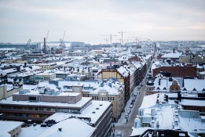 | A bird's-eye view of Helsinki in the winter. | Sakari Piippo | Images/Environment  Images/Environment/City | Environment  Clean  Environment  People
2 | 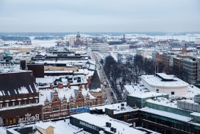 | A bird's-eye view of Helsinki in the winter. | Sakari Piippo | Images/Environment  Images/Environment/City | Environment  Clean  Environment  People
3 | 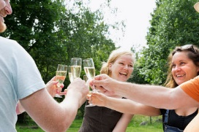 | A bubbly toast for summer | Katri Lehtola | Images/Environment  Images/Life and society  Images/Environment/Countryside | Life and Society  Family  Food  Leisure  People  Quality of life
4 | 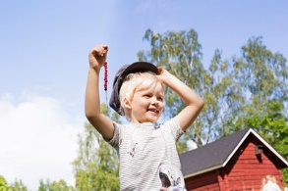 | A Finnish summer cottage | Katri Lehtola | Images/Environment  Images/Life and society  Images/Environment/Countryside | Life and Society  Family  Leisure  People  Quality of life
5 | 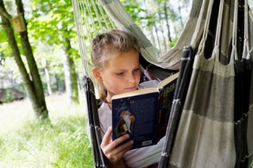 | A girl reading in hammock. | Katri Lehtola | Images/Environment  Images/Life and society  Images/Environment/Countryside | Life and Society  Family  Leisure  People  Quality of life
6 | 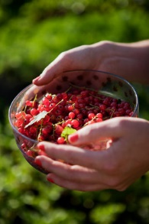 | Allotment garden | MMM/ Mavi/ Heli Sorjonen | Images/Environment  Images/Arts and culture  Images/Life and society  Images/Arts and culture/Urban culture  Images/Life and society/Food | Environment  Food  People  Life and society  Food  Leisure  Quality of life
7 | 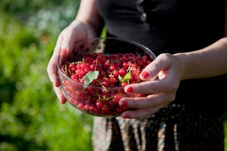 | Allotment garden | MMM/ Mavi/ Heli Sorjonen | Images/Environment  Images/Arts and culture  Images/Life and society  Images/Arts and culture/Urban culture  Images/Life and society/Food | Environment  Food  People  Life and society  Food  Leisure  Quality of life
8 | 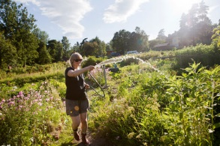 | Allotment garden | MMM/ Mavi/ Heli Sorjonen | Images/Environment  Images/Arts and culture  Images/Life and society  Images/Arts and culture/Urban culture  Images/Life and society/Food | Environment  Food  Life and society  Food  Leisure  Quality of life
9 | 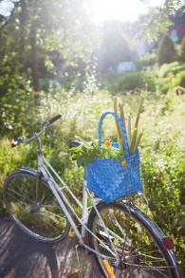 | Allotment garden | MMM/ Mavi/ Heli Sorjonen | Images/Environment  Images/Arts and culture  Images/Life and society  Images/Environment/Nature  Images/Arts and culture/Urban culture | Environment  Environment  Life and society  Food  Leisure  Quality of life
10 | 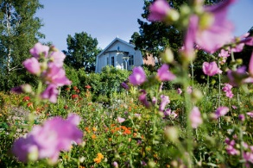 | Allotment garden | MMM/ Mavi/ Heli Sorjonen | Images/Environment  Images/Arts and culture  Images/Life and society  Images/Arts and culture/Urban culture  Images/Life and society/Food | Environment  Environment  Life and society  Leisure  Quality of life
11 | 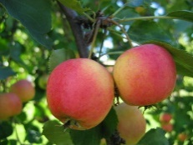 | Apples | MMM arkisto | Images/Environment  Images/Life and society  Images/Environment/Nature  Images/Life and society/Food | Environment  Food
12 |  | Baking a bilberry pie | Katri Lehtola | Images/Environment  Images/Life and society  Images/Environment/Countryside  Images/Life and society/Food | Environment  Clean  Food  Life and society  Family  Food  Leisure  People  Quality of life
13 | 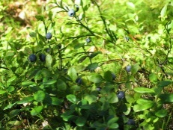 | Bilberries | MMM arkisto | Images/Environment  Images/Life and society  Images/Environment/Nature  Images/Life and society/Food | Environment  Food  Forest
14 | 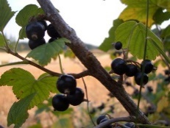 | Blackcurrant | MMM arkisto | Images/Environment  Images/Life and society  Images/Environment/Nature  Images/Life and society/Food | Environment  Food
15 | 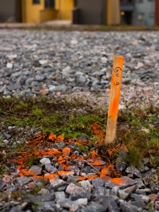 | Building a new suburb | Riitta Supperi/Keksi/Team Finland | Images/Environment  Images/Life and society  Images/Environment/Environmental protection | Arts and culture  City  Life and society  Quality of life  Society
11 | 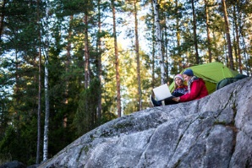 | Camping in Nuuksio-1 | Sakari Piippo | Images/Environment  Images/Environment/Nature | Camping  Nuuksio  Nature  Technology
12 | 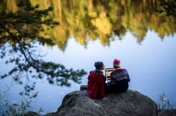 | Camping in Nuuksio-2 | Sakari Piippo | Images/Environment  Images/Environment/Nature | Camping  Nuuksio  Nature  Technology
13 | 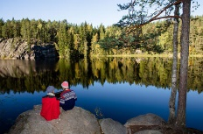 | Camping in Nuuksio-3 | Sakari Piippo | Images/Environment  Images/Environment/Nature | Camping  Nuuksio  Nature  Technology
14 | 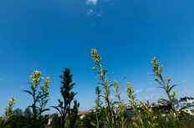 | Clean air | Jukka Rapo /Keksi /FIB | Images/Environment  Images/Environment/City | Environment  Clean
15 | 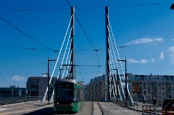 | Clean air in Helsinki | Jukka Rapo /Keksi /FIB | Images/Environment  Images/Environment/City | Environment  Clean
16 | 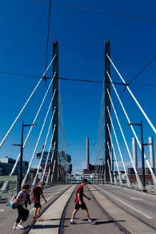 | Clean air in Helsinki-2 | Jukka Rapo /Keksi /FIB | Images/Environment  Images/Environment/City | Environment  Clean
17 | 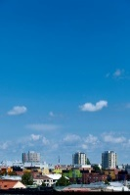 | Clean air in Helsinki-3 | Jukka Rapo /Keksi /FIB | Images/Environment  Images/Environment/City | Environment  Clean
18 | 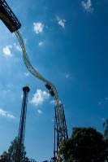 | Clean air2 | Jukka Rapo /Keksi /FIB | Images/Environment  Images/Environment/City | Environment  Clean
19 | 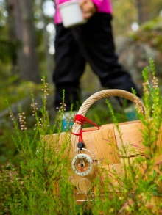 | Compass | Riitta Supperi/Keksi/Team Finland | Images/Environment  Images/Business and innovation  Images/Life and society  Images/Business and innovation/Innovations and Technology  Images/Environment/Nature | Arts and Culture  Design  Business and economy  Innovation  Knowledge  Environment  Forest  People
20 | 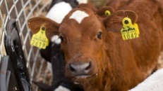 | Cow and organic milk | Riitta Supperi/Keksi/Team Finland | Images/Environment  Images/Environment/Countryside | Environment  Food  Organic
21 | 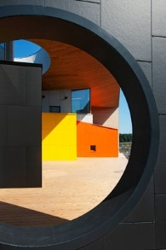 | Energy-efficient building | Jukka Rapo /Keksi /FIB | Images/Environment  Images/Business and innovation  Images/Life and society  Images/Business and innovation/Innovations and Technology  Images/Environment/Environmental protection  Images/Life and society/Finnish professionals | Business and economy  Knowledge  Life and society  Public service
22 | 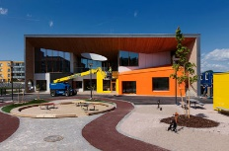 | Energy-efficient building 10 | Jukka Rapo /Keksi /FIB | Images/Environment  Images/Business and innovation  Images/Life and society  Images/Business and innovation/Innovations and Technology  Images/Environment/Environmental protection  Images/Life and society/Finnish professionals | Business and economy  Knowledge  Life and society  Public service
23 | 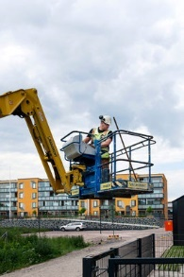 | Energy-efficient building 2 |  | Images/Environment  Images/Business and innovation  Images/Life and society  Images/Business and innovation/Innovations and Technology  Images/Environment/Environmental protection
24 | 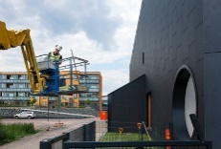 | Energy-efficient building 3 | Jukka Rapo /Keksi /FIB | Images/Environment  Images/Business and innovation  Images/Life and society  Images/Business and innovation/Innovations and Technology  Images/Environment/Environmental protection  Images/Life and society/Finnish professionals | Business and economy  Knowledge  Life and society  Public service
25 | 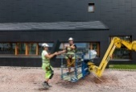 | Energy-efficient building 4 | Jukka Rapo /Keksi /FIB | Images/Environment  Images/Business and innovation  Images/Life and society  Images/Business and innovation/Innovations and Technology  Images/Environment/Environmental protection  Images/Life and society/Finnish professionals | Business and economy  Knowledge  Life and society  Public service
26 | 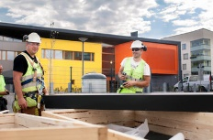 | Energy-efficient building 5 | Jukka Rapo /Keksi /FIB | Images/Environment  Images/Business and innovation  Images/Life and society  Images/Business and innovation/Innovations and Technology  Images/Environment/Environmental protection  Images/Life and society/Finnish professionals | Business and economy  Knowledge  Life and society  Public service
27 | 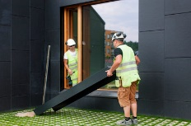 | Energy-efficient building 6 | Jukka Rapo /Keksi /FIB | Images/Environment  Images/Business and innovation  Images/Life and society  Images/Business and innovation/Innovations and Technology  Images/Environment/Environmental protection  Images/Life and society/Finnish professionals | Business and economy  Knowledge  Life and society  Public service
28 | 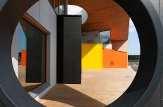 | Energy-efficient building 7 | Jukka Rapo /Keksi /FIB | Images/Environment  Images/Business and innovation  Images/Life and society  Images/Business and innovation/Innovations and Technology  Images/Environment/Environmental protection  Images/Life and society/Finnish professionals | Business and economy  Knowledge  Life and society  Public service
29 | 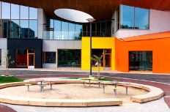 | Energy-efficient building 8 | Jukka Rapo /Keksi /FIB | Images/Environment  Images/Business and innovation  Images/Life and society  Images/Business and innovation/Innovations and Technology  Images/Environment/Environmental protection  Images/Life and society/Finnish professionals | Business and economy  Knowledge  Life and society  Public service
30 | 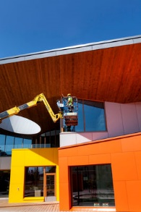 | Energy-efficient building 9 | Jukka Rapo /Keksi /FIB | Images/Environment  Images/Business and innovation  Images/Life and society  Images/Business and innovation/Innovations and Technology  Images/Environment/Environmental protection  Images/Life and society/Finnish professionals | Business and economy  Knowledge  Life and society  Public service
31 | 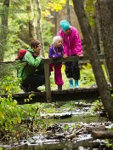 | Enjoying nature | Riitta Supperi/Keksi/Team Finland | Images/Environment  Images/Life and society  Images/Environment/Nature  Images/Life and society/Home and family | Environment  Forest  People  Water
32 | 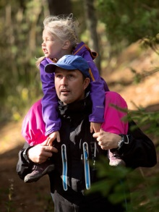 | Enjoying nature 2 | Riitta Supperi/Keksi/Team Finland | Images/Environment  Images/Life and society  Images/Environment/Nature  Images/Life and society/Home and family | Environment  Forest  People  Life and society  Child  Equality  Family
33 | 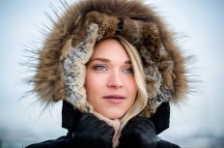 | Enjoying the view of Helsinki on a crispy winter day. | Sakari Piippo | Images/Environment  Images/Environment/City | Environment  Clean  Environment  People
34 | 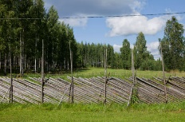 | Farm house visit | MMM/Mavi/Heli Sorjonen | Images/Environment  Images/Environment/Countryside | Environment  Environment  Life and society  Child  Leisure
35 | 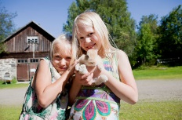 | Farm house visit | MMM/Mavi/Heli Sorjonen | Images/Environment  Images/Environment/Countryside | Environment  Environment  Life and society  Child  Leisure
36 | 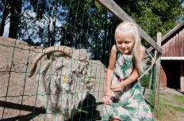 | Farm house visit | MMM/Mavi/Heli Sorjonen | Images/Environment  Images/Environment/Countryside | Environment  Environment  Life and society  Child  Leisure
37 | 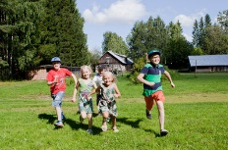 | Farm house visit | MMM/Mavi/Heli Sorjonen | Images/Environment  Images/Environment/Countryside | Environment  Environment  Life and society  Child  Leisure
38 | 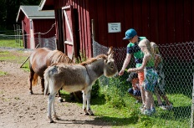 | Farm house visit | MMM/Mavi/Heli Sorjonen | Images/Environment  Images/Environment/Countryside | Environment  Environment  Life and society  Child  Leisure
39 | 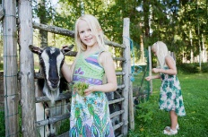 | Farm house visit | MMM/Mavi/Heli Sorjonen | Images/Environment  Images/Environment/Countryside | Environment  Environment  Life and society  Child  Leisure
40 | 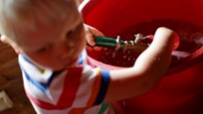 | Filling pail with water | Riitta Supperi/Keksi/Team Finland | Images/Environment  Images/Environment/Water | Lapsi  Vesi
41 | 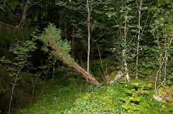 | Finnish nature-1 | Sakari Piippo | Images/Environment  Images/Environment/Nature | Nature  Forest
42 | 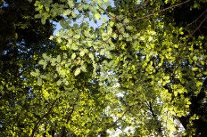 | Finnish nature-2 | Sakari Piippo | Images/Environment  Images/Environment/Nature | Nature  Forest
43 | 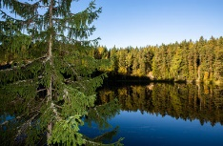 | Finnish nature-3 | Sakari Piippo | Images/Environment  Images/Environment/Nature | Nature  Forest
44 | 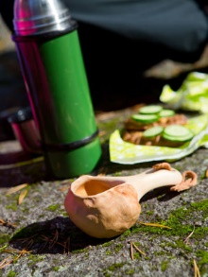 | Forest picnic | Riitta Supperi/Keksi/Team Finland | Images/Environment  Images/Life and society  Images/Environment/Nature | Environment  Food  Forest
45 | 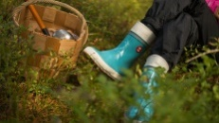 | Forest trip | Riitta Supperi/Keksi/Team Finland | Images/Environment  Images/Life and society  Images/Environment/Nature | Arts and culture  Design  Environment  Forest  People
46 | 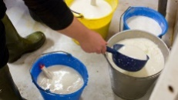 | Fresh organic milk | Riitta Supperi/Keksi/Team Finland | Images/Environment  Images/Environment/Countryside | Environment  Clean  Food  Organic
47 |  | Fresh tap water |  | Images/Environment  Images/Life and society  Images/Life and society/Home and family  Images/Environment/Water | Ihminen  Perhe  Puhdas  Vesi
48 |  | Fresh tap water |  | Images/Environment  Images/Environment/Water | Puhtaus  Vesi
49 | 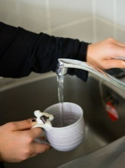 | Fresh tap water | Riitta Supperi/Keksi/Team Finland | Images/Environment  Images/Life and society  Images/Environment/Water  Images/Life and society/Food | Environment  Clean  Vesi
50 | 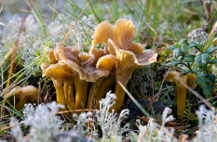 | Funnel chanterelle | MMM arkisto | Images/Environment  Images/Life and society  Images/Environment/Nature  Images/Life and society/Food | Environment  Environment  Food  Forest  Organic
51 | 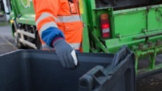 | Garbage maintenance | Riitta Supperi/Keksi/Team Finland | Images/Environment  Images/Life and society  Images/Environment/Environmental protection  Images/Life and society/Finnish professionals | Life and society  Public service  Recycling  Society  Work
52 | 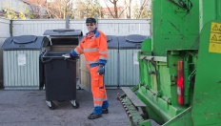 | Garbage maintenance 2 | Riitta Supperi/Keksi/Team Finland | Images/Environment  Images/Life and society  Images/Environment/Environmental protection  Images/Life and society/Finnish professionals | Life and society  Public service  Recycling  Society  Work
53 | 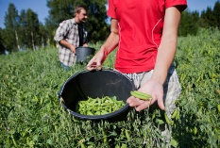 | Garden | MMM/Mavi/Heli Sorjonen | Images/Environment  Images/Life and society  Images/Environment/Nature  Images/Life and society/Food | Environment  Environment  Food
54 | 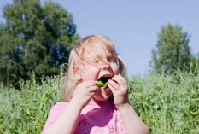 | Garden | MMM/Mavi/Heli Sorjonen | Images/Environment  Images/Life and society  Images/Environment/Nature  Images/Life and society/Food | Environment  Environment  Food
55 | 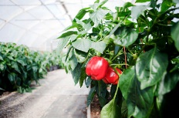 | Garden | MMM/Mavi/Heli Sorjonen | Images/Environment  Images/Life and society  Images/Environment/Nature  Images/Life and society/Food | Environment  Environment  Food
56 | 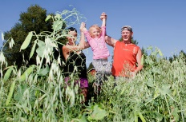 | Garden | MMM/Mavi/Heli Sorjonen | Images/Environment  Images/Life and society  Images/Environment/Nature  Images/Life and society/Food | Environment  Environment  Food
57 | 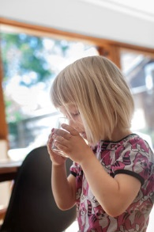 | Girl drinking water |  | Images/Environment  Images/Environment/Water | Life and society  Child  Vesi
58 | 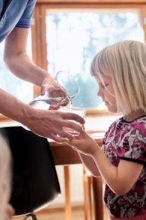 | Girl having some fresh water |  | Images/Environment  Images/Environment/Water | Lapsi  Perhe  Vesi
59 |  | Girls and fresh tap water |  | Images/Environment  Images/Environment/Water | Lapsi  Perhe  Vesi
60 | 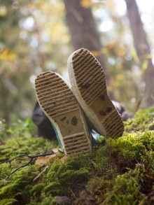 | Hai-boots in the nature | Riitta Supperi/Keksi/Team Finland | Images/Environment  Images/Life and society  Images/Environment/Nature | Arts and culture  Design
61 | 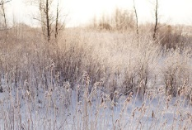 | Hailuoto in winter | Riitta Supperi/Keksi/Finland Promotion Board | Images/Environment  Images/Environment/Countryside | Environment  Clean  Environment  ---  Winter
62 | 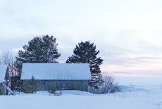 | Hailuoto in winter | Riitta Supperi/Keksi/Finland Promotion Board | Images/Environment  Images/Environment/Countryside | Environment  Clean  Environment  ---  Winter
63 | 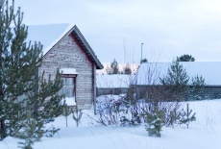 | Hailuoto in winter | Riitta Supperi/Keksi/Finland Promotion Board | Images/Environment  Images/Environment/Countryside | Environment  Clean  Environment  ---  Winter
64 | 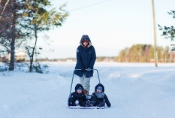 | Hailuoto in winter | Riitta Supperi/Keksi/Finland Promotion Board | Images/Environment  Images/Environment/Countryside | Environment  Clean  Environment  Life and society  Functionality  People  ----  Winter
65 | 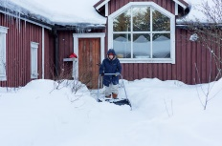 | Hailuoto in winter | Riitta Supperi/Keksi/Finland Promotion Board | Images/Environment  Images/Environment/Countryside | Environment  Clean  Environment  Life and society  Functionality  People  ----  Winter
66 | 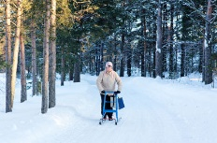 | Hailuoto in winter | Riitta Supperi/Keksi/Finland Promotion Board | Images/Environment  Images/Environment/Countryside | Environment  Clean  Environment  Life and society  Functionality  People  ----  Winter
67 | 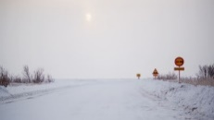 | Hailuoto in winter | Riitta Supperi/Keksi/Finland Promotion Board | Images/Environment  Images/Environment/Countryside | Environment  Clean  Environment  ---  Winter
68 |  | Hanging laundry to dry at a summer cottage. | Katri Lehtola | Images/Environment  Images/Life and society  Images/Environment/Countryside | Life and society  Family  Leisure  People  Quality of life
69 | 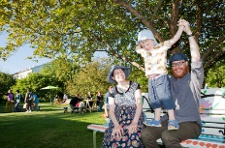 | Harvest Action & Family Market in Helsinki | MMM/ Mavi/ Heli Sorjonen | Images/Environment  Images/Arts and culture  Images/Life and society  Images/Arts and culture/Urban culture  Images/Life and society/Home & family  animals | Arts and culture  City  Environment  Environment  People  Life and society  Equality  Family  Leisure  Quality of life
70 |  | Harvest Action & Family Market in Helsinki | MMM/ Mavi/ Heli Sorjonen | Images/Environment  Images/Arts and culture  Images/Life and society  Images/Arts and culture/Urban culture  Images/Life and society/Food | Environment  Environment  Food  People  Life and society  Food  Leisure  Quality of life
71 | 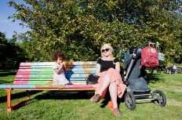 | Harvest Action & Family Market in Helsinki | MMM/ Mavi/ Heli Sorjonen | Images/Environment  Images/Arts and culture  Images/Life and society  Images/Arts and culture/Urban culture  Images/Life and society/Home &Family  Images/Life and society/Food | Arts and culture  City  Sustainability  Environment  Environment  People  Life and society  Family  Leisure  Quality of life
72 | 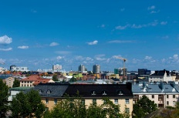 | Helsinki city view | Jukka Rapo /Keksi /FIB | Images/Environment  Images/Environment/City | Environment  Clean
73 | 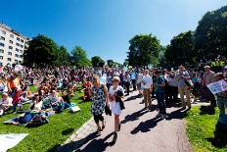 | Helsinki park festival | Jukka Rapo /Keksi /FIB | Images/Environment  Images/Arts and culture  Images/Arts and culture/Urban culture  Images/Environment/City | Environment  Clean
74 | 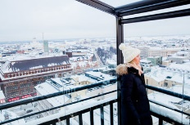 | Helsinki seen from one of the tallest buildings in the city centre. | Sakari Piippo | Images/Environment  Images/Environment/City | Environment  Clean  Environment  People
75 | 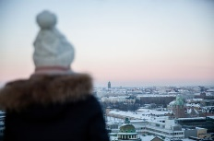 | Helsinki seen from one of the tallest buildings in the city centre.gs in the city centre. | Sakari Piippo | Images/Environment  Images/Environment/City | Environment  Clean  Environment  People
76 | 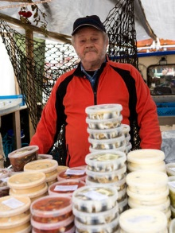 | Herring salesman | Riitta Supperi/Keksi/Team Finland | Images/Environment  Images/Arts and culture  Images/Life and society  Images/Environment/Countryside  Images/Arts and culture/Urban culture  Images/Life and society/Food | Arts and culture  City  Culture  Environment  Food  Organic  People
77 | 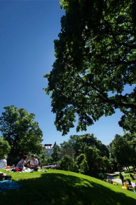 | In a park | Jukka Rapo /Keksi /FIB | Images/Environment  Images/Arts and culture  Images/Arts and culture/Urban culture  Images/Environment/City | Environment  Clean
78 | 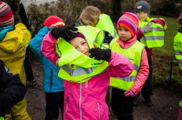 | Kids getting ready for a city excursion. | Sakari Piippo | Images/Environment  Images/Education  Images/Life and society  Images/Education/Day care  Images/Life and society/Traffic  Images/Environment/City | Education  Child  Day care  Life and society  Functionality  Public service  Society  Traffic
79 | 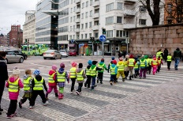 | Kindergarten kids crossing a road in a city. | Sakari Piippo | Images/Environment  Images/Education  Images/Life and society  Images/Education/Day care  Images/Life and society/Traffic  Images/Environment/City | Education  Child  Day care  Life and society  Functionality  Public service  Society  Traffic
80 | 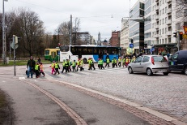 | Kindergarten kids crossing a street in a city | Sakari Piippo | Images/Environment  Images/Education  Images/Life and society  Images/Education/Day care  Images/Life and society/Traffic  Images/Environment/City | Education  Child  Day care  Life and society  Functionality  Public service  Society  Traffic
81 | 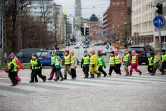 | Kindergarten kids crossing a street in a city | Sakari Piippo | Images/Environment  Images/Education  Images/Life and society  Images/Education/Day care  Images/Life and society/Traffic  Images/Environment/City | Education  Child  Day care  Life and society  Functionality  Public service  Society  Traffic
82 | 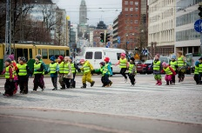 | Kindergarten kids crossing a street in a city | Sakari Piippo | Images/Environment  Images/Education  Images/Life and society  Images/Education/Day care  Images/Life and society/Traffic  Images/Environment/City | Education  Child  Day care  Life and society  Functionality  Public service  Society  Traffic
83 | 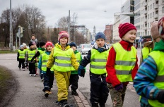 | Kindergarten kids on a city excursion | Sakari Piippo | Images/Environment  Images/Education  Images/Life and society  Images/Education/Day care  Images/Life and society/Traffic  Images/Environment/City | Education  Child  Day care  Life and society  Functionality  Public service  Society  Traffic
84 | 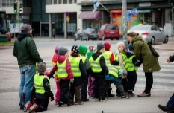 | Kindergarten kids preparing for a street crossing | Sakari Piippo | Images/Environment  Images/Education  Images/Life and society  Images/Education/Day care  Images/Life and society/Traffic  Images/Environment/City | Education  Child  Day care  Life and society  Functionality  Public service  Society  Traffic
85 | 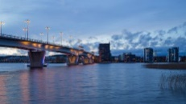 | Kuokkala bridge Jyväskylä | Riitta Supperi/Keksi/Team Finland | Images/Environment  Images/Environment/City | Arts and culture  City  Traffic
86 | 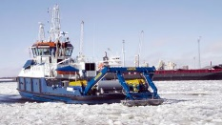 | Lamor Arctic oil recovery equipment Sternmax deployed from icebreaker Ahto in Torneo, Finland. Photo Lamor Corporation | Lamor Corporation Oy | Images/Environment  Images/Business and innovation  Images/Business and innovation/Business and economy  Images/Business and innovation/Business and technology  Images/Environment/Environmental protection  Images/Environment/Water | Business and economy  Business  Cleantech  Innovation  Knowledge  Technology  Environment  Clean  Environment  Water
87 | 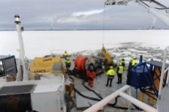 | Lamor oil recovery equipment deployed on icebreaker Kontio during an EMSA drill in the Gulf of Bothnia. Photo Lamor Corporation |  | Images/Environment
88 | 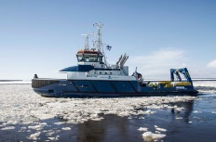 | Lamor oil recovery equipment Sternmax deployed from icebereaker Karhu, Gulf of Bothnia. Photo Lamor Corporation |  | Images/Environment
89 | 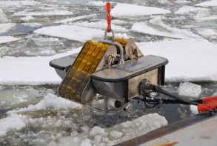 | Lamor oil recovery skimmer LFF100 deployed from icebreaker Kontio during an EMSA oil spill response exercie in the Gulf of Bothnia. Photo Lamor Corporation |  | Images/Environment
90 | 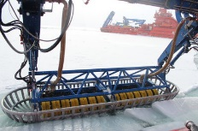 | Lamor Sternmax Arctic oil recovery equipment deployed in Russian Arctic Ocean. Photo Lamor Corporation |  | Images/Environment
91 | 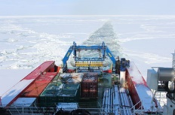 | Lamor Sternmax Arctic ooil recovery equipment onboard Russian IB Aleut, Arctic Ocean, Russia. Photo Lamor Corporation |  | Images/Environment
92 | 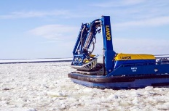 | Lamor Sternmax, the largest oil recovery equipment in the world with a recovery capacity of 400 m3 per hour, installed on icebreaker Ahto. Photo Lamor Corporation |  | Images/Environment
93 | 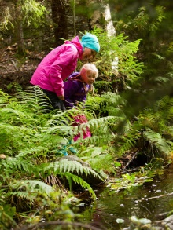 | Learning about forest life | Riitta Supperi/Keksi/Team Finland | Images/Environment  Images/Life and society  Images/Environment/Nature  Images/Life and society/Home & family | Environment  Forest  People  Water  Life and society  Child  Family
94 | 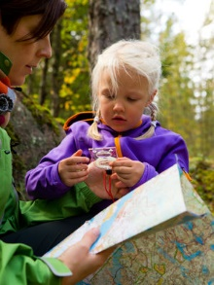 | Learning to orienteer in the nature | Riitta Supperi/Keksi/Team Finland | Images/Environment  Images/Life and society  Images/Environment/Nature  Images/Life and society/Home & family | Environment  Forest  People  Water  Life and society  Child  Family
95 | 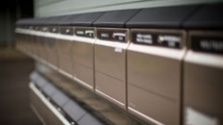 | Letter boxes | Riitta Supperi/Keksi/Team Finland | Images/Environment  Images/Life and society  Images/Environment/Environmental protection | Arts and culture  City  Life and society  Home  Quality of life
96 | 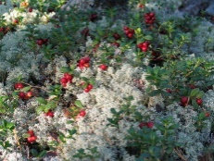 | Lingonberries | MMM arkisto | Images/Environment  Images/Life and society  Images/Environment/Nature  Images/Life and society/Food | Environment  Food  Forest
97 | 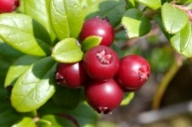 | Lingonberries | MMM arkisto | Images/Environment  Images/Life and society  Images/Environment/Nature  Images/Life and society/Food | Environment  Food  Forest  Organic
98 | 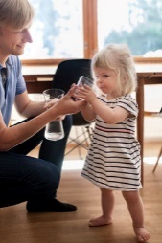 | Little girl drinking water |  | Images/Environment  Images/Environment/Water | Lapsi  Perhe  Vesi
99 | 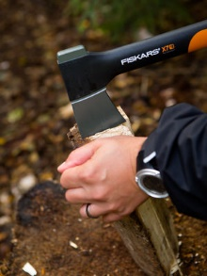 | Making firewood | Riitta Supperi/Keksi/Team Finland | Images/Environment  Images/Business and innovation  Images/Life and society  Images/Business and innovation/Innovations and technology  Images/Environment/Nature | Business and economy  Business  Knowledge  Environment  Forest
100 | 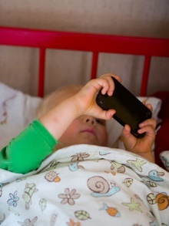 | Mobile in use in the summer house | Riitta Supperi/Keksi/Team Finland | Images/Environment  Images/Business and innovation  Images/Life and society  Images/Business and innovation/Innovations and technology  Images/Environment/Countryside  Images/Life and society/Home & family | Business and the economy  Game  Innovation  People  Technology  Life and society  Child
101 | 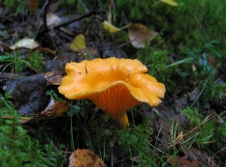 | Mushroom | MMM arkisto | Images/Environment  Images/Life and society  Images/Environment/Nature  Images/Life and society/Food | Environment  Food  Forest
102 | 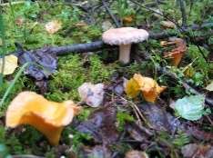 | Mushroom | MMM arkisto | Images/Environment  Images/Life and society  Images/Environment/Nature  Images/Life and society/Food | Environment  Food  Forest
103 | 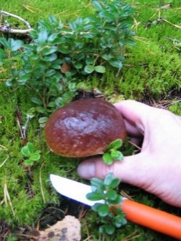 | Mushroom | MMM arkisto | Images/Environment  Images/Life and society  Images/Environment/Nature  Images/Life and society/Food | Environment  Food  Forest
104 | 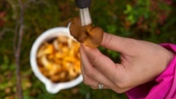 | Mushroom picking | MMM arkisto | Images/Environment  Images/Life and society  Images/Environment/Nature  Images/Life and society/Food | Environment  Food  Forest
105 | 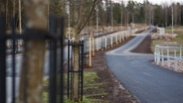 | New asphalt | Riitta Supperi/Keksi/Team Finland | Images/Environment  Images/Life and society  Images/Environment/Environmental protection | Arts and culture  City  Life and society  Home  Quality of life
106 | 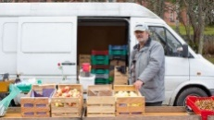 | Organic apple selling man | Riitta Supperi/Keksi/Team Finland | Images/Environment  Images/Life and society  Images/Environment/Countryside  Images/Life and society/Finnish professionals | Environment  Food  Organic  People
107 | 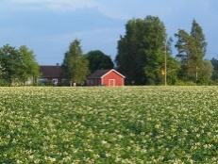 | Potato field | MMM arkisto | Images/Environment  Images/Life and society  Images/Environment/Countryside  Images/Life and society/Food | Environment  Food
108 | 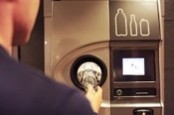 | Recycling | Emilia Kangasluoma/Team Finland | Images/Environment  Images/Environment/Environmental protection | Arts and culture  Recycling  Sustainability  Ekologisuus
109 | 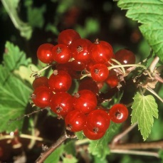 | Redcurrant | MMM arkisto/Elias af Hällström | Images/Environment  Images/Life and society  Images/Environment/Nature  Images/Life and society/Food | Environment  Food
110 | 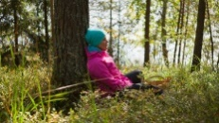 | Relaxing in the forest | Riitta Supperi/Keksi/Team Finland | Images/Environment  Images/Life and society  Images/Environment/Nature | Environment  Forest  People  Hyvinvionti  Luonto
111 | 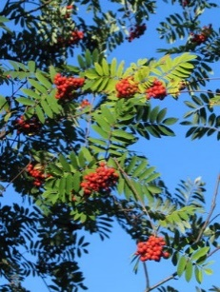 | Rowanberries | MMM arkisto | Images/Environment  Images/Life and society  Images/Environment/Nature  Images/Life and society/Food | Environment  Food
112 | 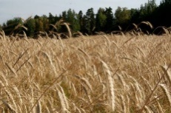 | Ryefield | MMM arkisto | Images/Environment  Images/Life and society  Images/Environment/Nature  Images/Environment/Countryside  Images/Life and society/Food | Environment  Environment  Food  Organic
113 | 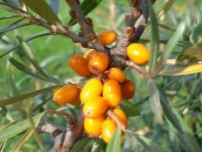 | Sea buckthorn | MMM arkisto/Maarit Perkonoja | Images/Environment  Images/Life and society  Images/Environment/Nature  Images/Life and society/Food | Environment  Food
114 | 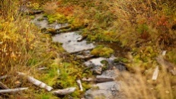 | Stream | Riitta Supperi/Keksi/Team Finland | Images/Environment  Images/Environment/Nature | Environment  Environment  Luonto
115 | 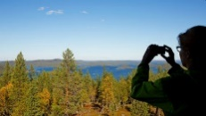 | Taking scenery pictures | Riitta Supperi/Keksi/Team Finland | Images/Environment  Images/Environment/Nature | Environment  Environment  Forest  People  Water  Wood  Life and society  Leisure
116 | 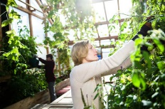 | Urban gardening | Sakari Piippo | Images/Environment | Urban  Gardening  ecologuu  Gardening
117 | 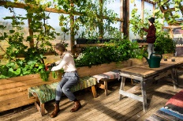 | Urban gardening-1 | Sakari Piippo | Images/Environment | Urban  Gardening  Green house  Gardening
118 | 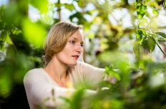 | Urban gardening-2 | Sakari Piippo | Images/Environment | Urban  Gardening  Green house  Gardening
119 | 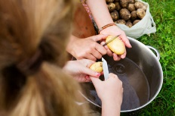 | Washing new potatoes. | Katri Lehtola | Images/Environment  Images/Life and society  Images/Environment/Countryside  Images/Life and society/Food | Environment  Clean  Food  Organic  Water  Life and Society  Family  Food  Leisure  People
120 | 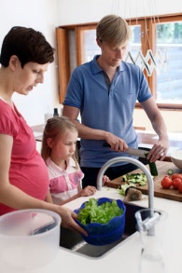 | Washing up salad |  | Images/Environment  Images/Environment/Water | Perhe  Puhtaus  Ruoka  Vesi
121 | 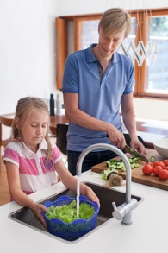 | Washing up salad |  | Images/Environment  Images/Environment/Water | Perhe  Puhtaus  Ruoka  Vesi
122 | 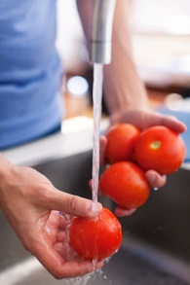 | Washing up tomatoes |  | Images/Environment  Images/Environment/Water | Perhe  Puhtaus  Ruoka  Vesi

Appendix 3

Background:

1. - Please tell me how you are connected with public diplomacy or nation branding or green branding? How is your work related to them?

- I am the Director of the Public Diplomacy Unit at the Ministry for Foreign Affairs of Finland and also General Secretary of the Finland Promotion Board (FPB), coordinating Nation branding in Finland. Please see attached presentation, also in terms of the role of the FPB.

Public diplomacy and Finnish brand:

2. - How would you define a national brand, what does it mean? I use the definitions of Simon Anholt, please familiarize with his studies in the matter, also useful is to read the document about Finlands' performance in the latest Nation Brands' Index (from Simon Anholt), from toolbox.finland.fi -> Research

- The shortest version is: All nation's have a brand, whether they want it or not and whether they work to enhance it or not. It is a lot of different rivers (history, geographical location, wars, known personalities, political decisions, government actions, the people of the country, the products, the cultural expressions and phenomena, sports, etc etc) flowing together. The interesting part is that after the first impression of a country is made in our head (during teenage years) it rarely and very slowly changes.

3. - How would you define the key elements of the Finnish brand?

- They have been very thoroughly studied in the country brand group that finished its work 2010 (the report is in Finnish in the Finland Toolbox). Key elements: 1) Importance of nature, 2) Problem-solving mentality, 3) Education

4. - Has Finland got a branding strategy?

- Yes. A part from the report from 2010 that we use as a backdrop for everything we do, Finland Promotion Board has a longer term and yearly strategy and emphasis on certain issues & defines the story of Finland for that issue as well as the main messages.

5. - How Finland’s brand and Finnish public diplomacy are connected with each other?

- We don't really talk so much about Public diplomacy anymore as a separate area of work. It is included and streamlined into basically almost everything our embassies do (as well as digital diplomacy). The two are very intervowen, for example in how we define priority countries or finance embassy activities.

- - Who are the key actors in Finnish public diplomacy and national branding?

- MFA, Prime Minister's office, Ministry of economy and labour, Ministry of education, Finpro (includes Export Finland, Invest in Finland, Visit Finland), city of Helsinki, House of Lapland & Lapland broadly speaking, other cities and areas, Finnish National agency for education, Cultural institutes (independent), Tekes, companies, NGO's (like CMI), and all the Finns.

7. - How would you evaluate the Finnish brand? Could you name a couple of strengths and a couple of weaknesses of the strategy?

- It is very much studied, so now point in personal opinions ☺ Please be referred to the Nation Brands Index report I mention above. All in all, Finland performs very well, and definitely punches way above its weight, in issues related to education, how our government and society is perceived, functionality and exports, ie in the "facts section". Finland could still improve in the way Finland is perceived as a tourist attraction and how our culture and cultural phenomena are known, ie in the "fun sector".

Green branding:

8. - Do you think that Finland has a strong green brand? What does it include?

- Yes, very much so. It includes success in rankings (pls be referred to the Toolbox -> Images -> Rankings). Biotecnology and cleantech in all its forms, smart cities and waste to energy. Amount of forests and tourism opportunities.

9. - What place does the “green” brand have in Finnish public diplomacy? Nature and solutions that work, and solve many of our common problems including the ones related to pure air, water etc. are essential strengths.

10. - Who are the main actors in the field of green branding? What does the Finnish government do to make Finland “green branded”?
- There is an underlying assumption in the question that branding is a label simply put on something, advertising etc. This is not the case. We tell about Finland the way it is, and about its strengths. We don't have a special "green branding" strategy or goals.

11. - In your view, what other aspects, besides green branding, would contribute in promoting the brand Finland, if included in the strategy of national branding?

- I think all of this is also included in the Toolbox. By looking at the choices we have made in the Presentations folder in Toolbox, you can pretty well see what we emphasize, I think. Maybe the one thing that has not been told here yet, is equality between people and genders.

